Aircraft Systems Online Learning Module
Lucero Duran Trinidad
EDCI569
Purdue University
Project Background
Subject
One of the majors provided at the School of Aviation and Transportation Technology (SATT) at Purdue University is Professional Flight. In this major, students are able to obtain the pilot licenses, knowledge, and skills necessary to become professional pilots for an airline or corporate position. One course that students have to take in this major is AT25302 Commercial Flight. The goal of this course is for students to obtain both an instrument rating and a commercial pilot’s license.
Per the Federal Aviation Regulations (FARs) an individual wanting to obtain a commercial pilot’s license must complete a checkride, which consists of both an oral and flight section (FAA, 2018). In a checkride an applicant is assessed on various subject areas that include aircraft systems, weather theory, cross country planning, etc. for the oral section and various maneuvers for the flight section. When one of the subject areas or maneuvers does not meet standards, then the chekride is given an “Unsatisfactory Performance” (FAA, 2018). Whenever an “Unsatisfactory Performance” is given, it is placed in the flight school’s record, thus affecting its pass rate.
In order for the school to maintain its training certificate with the Federal Aviation Administration (FAA), it must ensure an 80% pass rate on checkrides. For this reason, it’s imperative that students in SATT’s flight program are knowledgeable on all subject areas to meet and/or exceed standards on a checkride. From interviews conducted with Designated Pilot Examiners (DPE) and SATT instructors, it has been determined that students enrolled in AT25302 are lacking in various knowledge areas that affect their performance on the oral exam. One area of concern that the interviews revealed was poor performance on aircraft systems.
Learning context
One possible solution that has been proposed to help increase student knowledge in these subject areas, to pass the oral section of the checkride, is the creation of an online training module. The training module will be designed as a self-paced module to allow for diversity in student learning characteristics, allow for unlimited attempts of completion for students who may want to re-take the course for additional review, and be designed in a sideways sequence to allow students to skip through any material they may already know.
The online module as a solution to this need is feasible as it would be easily distributed to the students, by adding a link to the course on Blackboard or through email, and it would be available to them at any time and place. In addition, an online module would be able to be used as a homework assignment or extra resource that students would be able to complete in addition to the face-to-face time they have with their flight instructor.
Scope
In order to meet the time restrictions on the project and have a feasible product, the scope of the training module will focus on one aircraft system. From the DPE and instructor interviews, it was determined that the aircraft system with the least amount of knowledge is the landing gear system in a Piper Arrow. Therefore, the instructional goal for this learning module is:
To teach students enrolled in AT25302 the landing gear system in a Piper Arrow to the standards set forth in the Airman Certification Standards.
Front-End Analysis
Client and Learners
Since this course is designed to meet a need for the SATT flight school, the client for this project is the Chief Flight Instructor of the program, or her designee. The Chief Flight Instructor, or designee, will help evaluate the course, at various stages of the process, for content quality and ensuring the school’s requirements are met. The learners for this course are described in Table 1. Learner Analysis.
Target Learner Analysis. The learners for this course will include sophomores in their second semester at Purdue taking AT25302 Commercial Flight, which would put them around the ages of 19-22, with the exception of a few older students considered “non-traditional” college students. Table 1 Learner Analysis provides a more detailed learner analysis that provides motivations, characteristics, and prior knowledge and skills. The information presented in Table 1 was gathered through interviews of learners, observations of learners, and school data records.
Table 1. Learner Analysis
Who | Young adults enrolled in the Professional Flight Program.  - The students would be sophomores enrolled in AT25302 Commercial Flight.  - The students may also be older adults, considered “non-traditional” college students.  - Majority of students in the program are male and Caucasian, thus a small amount of females and minorities are expected in the course.
Motivations | This course a core requirement for the Professional Flight Program. This course must be taken prior to enrolling in AT35300 as it meets the prerequisites for the multi-engine rating course.
- A passing grade and checkride must be attained in order to continue in the program. As such, a student will try to not re-take the class as that may put them a semester behind and incur more flight fees.
- The material provided is such that will need to be retained in the long-term as pilots will use it for the rest of their career. Therefore, students will try to comprehend the material to ensure material stores in long-term memory.
Characteristics/Constraints | Age:  - Most will be college students, therefore learning rate will be similar.  - Sometimes have older individuals whose learning rate is different than college students. Also, these individuals may have been separated from academia for a time that learning and studying techniques may have to be retaught.  Time:  - Students are enrolled in a flight course, which requires a high time commitment; thus, students may not have much time left for studying or doing this course.  - Students could be enrolled in ROTC, which can have high time commitments as well.  - Other classes or extra-curricular activities (clubs, sports, etc) may limit the time outside of class for studying and doing this course.  - Some students may have family or work responsibilities (mostly older individuals) that can affect time availability.  Technology:  - Depending on backgrounds, students may have a strong or weak knowledge of technology use.  - Students may not have technological devices with them, or may have limited access. Devices can include, laptop, iPad, tablet, smart phone, etc.  - If students were to take course at home, there may have limited access to internet access.
Prior Knowledge/Skills | Depending on the background of student, he/she may have some landing gear system knowledge obtained from other training experience outside of Purdue’s flight school.

Learning Environment
To deliver this course as an online learning module, an LMS system will be used for ease of access and availability. The potential platforms being evaluated are Moodle and Talent LMS. Once further evaluation is done, the platform used will incorporate various delivery methods for content that will aid in engagement and interaction of learners. In addition, the course will provide assessment activities to ensure information is retained for later recall. Lastly, the course will also include a section for textual resources, including aircraft manuals, systems diagrams, and system description guides, that students may be able to use. The following paragraphs provide more information on the delivery methods, intended instruction, and assessment plan.
Delivery Method. From a quick evaluation of LMS platform, the platform that will be used for this course is Talent LMS. This platform was selected as it is easily accessible to all students, as long as a free account is created, it is compatible with any electronic device, including mobile devices, and it is easy to use for the designer. Further, the presentation style for Talent LMS is clean and professional. For the presentation of content, there are various technologies that will be used.
One technology is PowerPoint Presentations. Slides of content will be created to provide information to learners in a textual format. This format will allow students to download and print the presentations if they desire for use in the future. In addition, these slides will be able to be used a content “Items” in the Talent LMS website. A second technology that will be used is PowToon. Through this tool, animation videos will be created to provide textual content that would be better understood by leaners if imagery were to be used. The animation videos will provide a change from just presentations and increase engagement in learners.
A third technology to be used will be videos created by the course designer, also SME, to provide content that is not conductive to textual presentation. These videos will consist of explanations of the operation of systems, walk-throughs of the system with an actual aircraft, etc. The videos will be taken with the designer’s iPhone X Camera option and edited through Microsoft Movie Maker. These tools were selected due to their familiarity to the course designer, as the time frame may not allow learning many new technologies. Lastly, Youtube videos may be incorporated into the course if the quality and quantity of the content presented is deemed acceptable to meet the learning objectives for this course.
Intended Instruction. This course will be provided as an online standalone self-paced format. This format will allow students to access the course at whatever time and wherever they might be. Also, students will be able to pace themselves based on their personal characteristics of learning and will allow them to take the course as many times as necessary. This way, if a student would like to do “last-minute review” before an exam, he/she may be able to do so.
The following table provides the proposed instruction based on the learning objectives created for this course.
Table 2. Intended Instruction of Online Course
Item/Objective | Content
Introduction | A brief introduction of the course to include instructions of how to navigate, present learning goal, and reasons the course was created.
Part 1 - Learning Objective 1:  The course will teach the Piper Arrow’s landing gear system components and operation to students enrolled in AT25302 who will be able to describe the landing gear system components and operation to Airman Certification Standards. | Absorb:  - The course will start with presentation of PowerPoint slides to include:  - General overview of landing gear system  - Breakdown of various components to include: system components and in-cockpit indications. Emphasis placed on the system components.  - Using a video or PowToon animation:  - Present the operation of the components that make the landing gear system.  - Include a link to the Resources section of the course, to provide aircraft manual if they would like it.  Do:  - This section will include practice activities. It will include a quiz to assess the learner’s knowledge of the operation of the system. Multiple Choice quiz.
Part 2 – Learning Objective 2:  The course will teach the location of all landing gear system components in a Piper Arrow to students enrolled in AT25302 who will be able to demonstrate these locations to the satisfaction of the flight instructor. | Absorb:  - Using a video created by SME with either the designer or a maintenance technician:  - With an aircraft apart, point out the components of the system.  Do:  This section will include a quiz to assess the learner’s knowledge of location of components in an aircraft. This will be matching quizzes.  Connect:  This section will ask learners to create a short video or picture collage describing and pointing out location of the components of system. Help from an instructor or maintenance technician will be encouraged/allowed. The video/picture collage can be submitted via email to SME if feedback is required by learners.
Part 3 – Learning Objective 3:  The course will teach the Piper Arrow’s landing gear system indications, including in-cockpit annunciator lights and landing gear position lights, to students enrolled in AT25302 who will be able to identify the cause of the indication and explain it to Airman Certification Standards. | Absorb:  - Using a PowerPoint presentation, embedded with pictures taken by designer, will present  - The annunciator lights associated with landing gear system with description of causes for illumination  - Landing gear positions lights and when they turn on/off.  - Landing gear horn and causes for it going off  Do:  This section will include a quiz to assess the learner’s knowledge of causes of annunciation lights, position lights, and gear horn. The quiz will be at the end of this section. These quizzes will most likely by fill in the blank or matching.
Part 4 – Learning Objective 4:  The course will teach emergency situations and courses of action relating to the landing gear system in a Piper Arrow to students enrolled in AT25302 who will be able to select the best course of action from various abnormal or emergency situations. | Absorb:  - The course will start with presentation of PowerPoint slides to include:  - Emergency Gear Extension  Do/Connect:  This section will include two case studies for the students (presented either in textual format, PowerPoint slide, or PowToon video). Students will then be asked questions (short quiz) on the case studies to determine if they correlate information from Part 3 and Part 4. The case study topics are:  - Emergency gear extension – will have to correlate landing position lights and gear horn with the emergency information provided in this section.
Part 5 – Learning Objective 5:  The course will teach the airworthiness requirements relating to the Piper Arrow’s landing gear system to students enrolled in AT25302 who will be able to explain the requirements to Airman Certification Standards. | Absorb:  - Using PowerPoint slides, will present  - Airworthiness requirements necessary for the Piper Arrow landing gear system required by the FAA.  - Include pictures of the airworthiness logbook to show examples.  Do:  This section will include a quiz to assess the learner’s knowledge of the airworthiness requirements. This quiz will be multiple choice.
Conclusion | Connect Activity:  In this section learners will be asked to use all the knowledge they have gained through the course. Students will be presented with an example of a one-page system guide (similar to a job aid) that can be used as a resource during a checkride or for future studying. The leaners will be asked to create one for the landing gear system so they can have for future use. The learners will have complete authority and creativity to create their guides.

Assessment Plan. The assessment for this course varies between various quizzes and activities. Details can be found in Table 2. Intended Instruction of Online Course. Each objective includes a quiz or connect-type activity to act as summative assessment. This will ensure learners are engaged and that the content presented will be retained. For the quizzes, if a learner gets a question wrong, feedback will be provided to direct them to the section, slide, or video that they would have to review. The quizzes will have unlimited attempts to allow leaners to take quiz as many times as they would like. In order to continue to the next section of the course, students will have to get at least an 80% correct on the quizzes. The decision to create the quizzes as either multiple choice, fill in the blank, or matching was determined based on the content to be presented in each part. As the designer is also the SME, these quizzes were designed to fit the content to ensure retention.
For the summative assessment, the course includes it in the Conclusion section (See Table 2. Intended Instruction of Online Course for details). Although this assessment will not be graded by the course, learners will eventually receive feedback from their flight instructor. The decision to have this assessment was to create a short guide that students could reference as they continue to study for the checkride, to use in a face-to-face meeting with their flight instructor, or to use as a resource during the checkride. It is the hope of the designer, that this short guide will be reviewed by the learner’s individual flight instructor. There will also be an option to send the guide via email to the SME/designer of the course if the learner would like feedback.
Objectives
For this course, the following learning objectives were created using Horton (2012) method.
- The course will teach the Piper Arrow’s landing gear system components and operation to students enrolled in AT25302 who will be able to describe the landing gear system components and operation to Airman Certification Standards.
- The course will teach the location of all landing gear system components in a Piper Arrow to students enrolled in AT25302 who will be able to demonstrate these locations to the satisfaction of the flight instructor.
- The course will teach the Piper Arrow’s landing gear system indications, including in-cockpit annunciator lights and landing gear position lights, to students enrolled in AT25302 who will be able to identify the cause of the indication and explain it to Airman Certification Standards.
- The course will teach emergency situations and courses of action relating to the landing gear system in a Piper Arrow to students enrolled in AT25302 who will be able to select the best course of action from various abnormal or emergency situations.
- The course will teach the airworthiness requirements relating to the Piper Arrow’s landing gear system to students enrolled in AT25302 who will be able to explain the requirements to Airman Certification Standards.

Storyboard
A storyboard was created for this course to help the stakeholders and designer understand how the course will be created, how the learners will use and interact with the online course, the navigation aspects of the course, and general display of the course on Talent LMS. As the storyboard includes 24 slides of information, it has been included in Appendix A. Appendix A can be found at the conclusion of this document.

Site Map
To further understand the navigation of the online course, a site map was created and represented in Figure 1 on the next page. The site map represents the navigation options of the course, which corresponds to a sideways sequence design. The course is set to allow learners to “jump around” in the course to allow for any pace of learning and learning style. Additionally, with this design learners will be able to come back to the course at any time and take any section of the course.

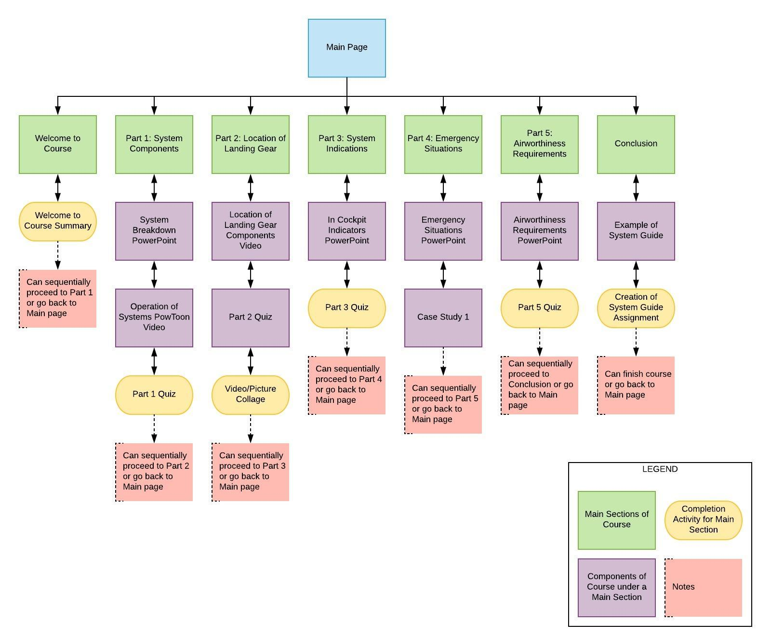
Figure 1. Sitemap of Online Course

Instructional Content
The instructional content for this course has been created and can be found in Appendix B of this document. The content includes the PowerPoint presentations, PowToon videos, SME video, case study, and sample systems guide.
Assessments
The assessments for this course have been created and can be found in the Table 3. The table provides the learning objectives and corresponding assessments.
Table 3. Course Assessments
Learning Objective | Assessments
Part 1 - Learning Objective 1:  The course will teach the Piper Arrow’s landing gear system components and operation to students enrolled in AT25302 who will be able to describe the landing gear system components and operation to Airman Certification Standards. | This section will include three types of assessment.  A multiple-choice quiz (2 Questions) after the presentation of system breakdown  - The landing gear in the Piper Arrow has how many squat switches?  - 1*  - 2  - 3  - The nose wheel strut, has two extra components, what are these?  - Brakes and micro-switches  - Shimmy dampener and scissor link*  - Springs and squat switch  A fill in the blank quiz (2 Questions) after the presentation of operation of system.  - To keep the gear in the up position, ___________ ____________ is required.  - The choices: Hydraulic pressure* or Mechanical locks  - To move the gear (extend/retract) the system requires a ________ _________.  - The choices: electric pump* or hydraulic pump.  A “summative” assessment for this section that includes a 5 multiple-choice question quiz.  - In order for the hydraulic pump to work, what other aircraft system must be operational?  - Electrical system*  - Fuel system  - Vacuum system  - Which of the following components are inside the cockpit?  - Landing gear position lights*  - Micro-switches for the gear position lights.  - Springs to assist in keeping gear in down position  - In order to maintain the landing gear in the down position, the system uses mechanical locks and springs.  - False  - True*  - When we use the emergency gear extension lever, what are we doing to the system?  - Operating the electric pump to send fluid to down chamber and bringing gear down.  - Releasing the hydraulic pressure by opening a valve that lets fluid back to the reservoir.*  - Releasing the hydraulic pressure by opening a valve that leaks the fluid out of the lines.  - The Piper Arrow is considered a  - Retractable gear airplane  - Tricycle gear airplane  - All of the above*
Part 2 – Learning Objective 2:  The course will teach the location of all landing gear system components in a Piper Arrow to students enrolled in AT25302 who will be able to demonstrate these locations to the satisfaction of the flight instructor. | This section will include three assessments.  A fill in the blank quiz (2 Questions) to assess the learner’s knowledge of location of components in an aircraft.  - The landing gear hydraulic fluid reservoir is located in the __________________.  - The choices: behind baggage compartment*, landing gear strut, in the wing.  - The __________ _________ is located only on the nose wheel strut.  - The choices: shimmy dampener*, springs, micro-switches.  A “summative” assessment for this section that includes a 5 matching-question quiz.  - Match the component of the landing gear with its location on the aircraft.  - Electric gear pump – behind baggage compartment  - Emergency gear extension lever – pilot side inside cockpit  - Oleo struts – all three struts  - Squat switch – left main strut  - Scissor link – nose wheel strut  Learners may create a short video or picture collage describing and pointing out location of the components of system. Help from an instructor or maintenance technician will be encouraged/allowed. The video/picture collage can be submitted via email to SME if learners request feedback.
Part 3 – Learning Objective 3:  The course will teach the Piper Arrow’s landing gear system indications, including in-cockpit annunciator lights and landing gear position lights, to students enrolled in AT25302 who will be able to identify the cause of the indication and explain it to Airman Certification Standards. | This section will include one assessment of 3 questions, multiple choice.  - The landing gear annunciator light will turn on when:  - All three struts are not in same position (all up or all down).*  - The gear pump malfunctions  - The squat switch is inoperative  - The landing gear position lights will not turn on during the day if the navigation lights switch is turned on.  - True*  - False  - What are the instances that the landing gear horn will go off in the cockpit?  - When the throttle is less than 14” MAP  - When the flaps are set to 25 degrees or higher  - Both of the above*
Part 4 – Learning Objective 4:  The course will teach emergency situations and courses of action relating to the landing gear system in a Piper Arrow to students enrolled in AT25302 who will be able to select the best course of action from various abnormal or emergency situations. | This section includes one assessment of 3 questions multiple-choice that will be answered after the case study is presented.  - What are the first steps you should take to deal with this issue?  - Continue with the maneuver, recover, and then grab the emergency gear extension checklist.  - Stop the maneuver and grab the emergency gear extension checklist *  - Stop the maneuver and pull the emergency gear extension lever  - On the emergency gear extension checklist, why does it asks us to slow down prior to engaging the emergency gear extension lever?  - To reduce damage on the struts and gear doors when free-falling *  - To make the aircraft easier to fly while doing the checklist  - To ensure you will not hit other aircraft since you are not flying that fast  - When we engage the emergency gear extension lever, are we able to bring the gear up?  - No, we have released the hydraulic fluid in the system by opening a release valve.*  - Yes, the gear came down due to gravity, but our electric pump still works.
Part 5 – Learning Objective 5:  The course will teach the airworthiness requirements relating to the Piper Arrow’s landing gear system to students enrolled in AT25302 who will be able to explain the requirements to Airman Certification Standards. | This section will include one assessment of 2 questions, multiple choice.  - Under Purdue’s progressive maintenance system, which event is the landing gear checked?  - Event 1  - Event 2  - Event 3 *  - How often does the landing gear inspection need to be done?  - At least once a year *  - Every 90 days  - Once every 6 months
Conclusion | In this section, learners will be presented with an example of a system guide. The learners will be asked to create one for the landing gear system. The system guide can be submitted via email to SME if learners request feedback.

Merrill’s 5 Star Rating
The following table provides Merrill’s 5 Star Instructional Design Rating for this course.
Type of Instruction:
Stage | Criteria |  | Explanation
PROBLEM  Is the courseware presented in the context of real world problems? | Does the courseware show learners the task they will be able to do or the problem they will be able to solve as a result of completing a module or course? |  | The course provides some real world scenarios in the case study and in the conclusion section of the course. The rest of the course focuses on presenting the information as is, and not really tying it to any real world scenario or problem.  From the course, the learners are engaged throughout the course by multiple assessments. The assessments however are independent of each other and don’t build on one another. This was done to engage learners and make sure content is transferring to learners.
 | Are students engaged at the problem or task level not just the operation or action levels?
 | Does the courseware involve a progression of problems rather than a single problem?
RATING FOR PROBLEM STAGE: |  |  | BRONZE
ACTIVATION  Does the courseware attempt to activate relevant prior knowledge or experience? | Does the courseware direct learners to recall, relate, describe, or apply knowledge from relevant past experience that can be used as a foundation for new knowledge? |  | Although not directly, the learners are asked to use prior experience in flying airplanes and simple system knowledge to comprehend the material presented.  In order to understand how the landing gear operates, learners must have some basic knowledge of simple aircraft systems (hydraulics, gear struts, electrical system) to ensure transfer of knowledge. Also, in the airworthiness section, learners are asked to remember all the airworthiness requirements for an aircraft, while the content only focuses on the landing gear.
 | Does the courseware provide relevant experience that can be used as a foundation for the new knowledge?
 | If learners already know some of the content are they given an opportunity to demonstrate their previously acquired knowledge or skill.
RATING FOR ACTIVATION STAGE: |  |  | SILVER
DEMONSTRATION  Are the demonstrations (examples) consistent with the content being taught? | Are the demonstrations (examples) consistent with the content being taught?  - Examples and non-examples for concepts?  - Demonstrations for procedures?  - Visualizations for processes?  - Modeling for behavior? |  | For this course, mostly PowerPoint presentations and videos were used. Since the content in each section was relatively small, PowerPoint presentations were the most viable for content presentation.  The course did not present the same content in various formats, instead used just one format and moved on to the next content area. This was done to not appear repetitive and make the course longer than it should be.  The media used for the course is relevant as it is able to present the information properly and simply.
Are at least some of the following learner guidance techniques employed?
- Learners are directed to relevant information?
- Multiple representations are used for the demonstrations?
- Multiple demonstrations are explicitly compared?
 | Is media relevant to the content and used to enhance learning?
RATING FOR DEMONSTRATION STAGE: |  | SILVER
APPLICATION  Are the application (practice) and the posttest consistent with the stated or implied objectives? | Are the application (practice) and the posttest consistent with the stated or implied objectives?  - Information-about practice requires learners to recall or recognize information.  - Parts-of practice requires the learners to locate, name, and/or describe each part.  - Kinds-of practice requires learners to identify new examples of each kind.  - How-to practice requires learners to do the procedure.  - What-happens practice requires learners to predict a consequence of a process given conditions, or to find faulted conditions given an unexpected consequence. |  | All the assessments used in this course are tied back to the objectives. They represent the information presented and have learners used this new knowledge to answer the questions.  In the course, feedback will be provided to learners if answers are wrong. Then they will have the option to re-take the assessment.  There is no coaching in the course, except for feedback provided in case of wrong answer. Of course, this does not mean a learner taking the course can not ask help from an instructor with the content. They will just have to do that on their own.
 | Does the courseware require learners to use new knowledge or skill to solve a varied sequence of problems and do learners receive corrective feedback on their performance?
 | In most application or practice activities, are learners able to access context sensitive help or guidance when having difficulty with the instructional materials? Is this coaching gradually diminished as the instruction progresses?
RATING FOR APPLICATION STAGE: |  | GOLD
INTEGRATION  Does the courseware provide techniques that encourage learners to integrate (transfer) the new knowledge or skill into their everyday life? | Does the courseware provide an opportunity for learners to publicly demonstrate their new knowledge or skill? |  | The learners are provided with two activities that would allow them to demonstrate the use of their new knowledge. This includes creating a video/picture collage and a systems guide that they may be able to use later or share with other students or instructors.
 | Does the courseware provide an opportunity for learners to reflect-on, discuss, and defend their new knowledge or skill?
 | Does the courseware provide an opportunity for learners to create, invent, or explore new and personal ways to use their new knowledge or skill?
RATING FOR INTEGRATION STAGE: |  | BRONZE

References
Federal Aviation Administration (FAA). (2018). Federal Aviation Regulations/Aeronautical Information Manual. U.S. Department of Transportation.
Horton, W. (2012). E-Learning by design. San Francisco, CA: John Wiley and Sons, Inc.

Appendix A
Online Course Storyboard

Online Course Storyboard

The following pages represent the storyboard for the online course. The first two figures provide information on the course in general, while the rest represent the storyboard of the course itself.

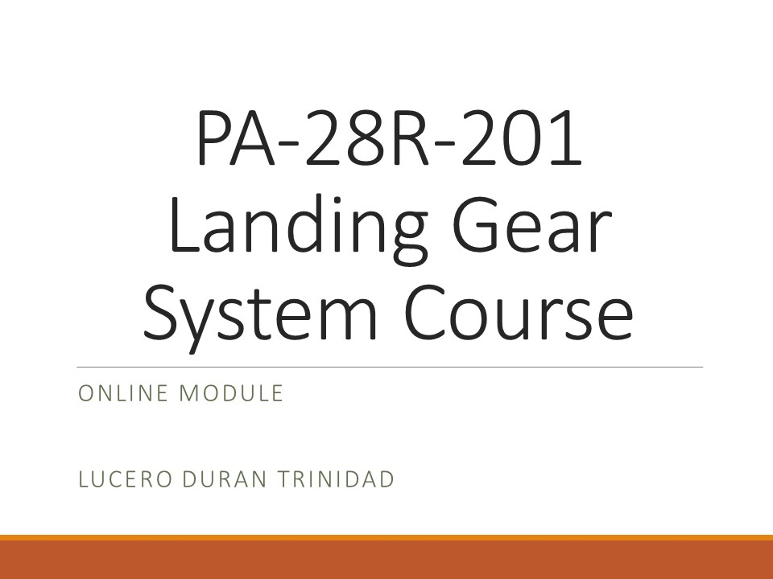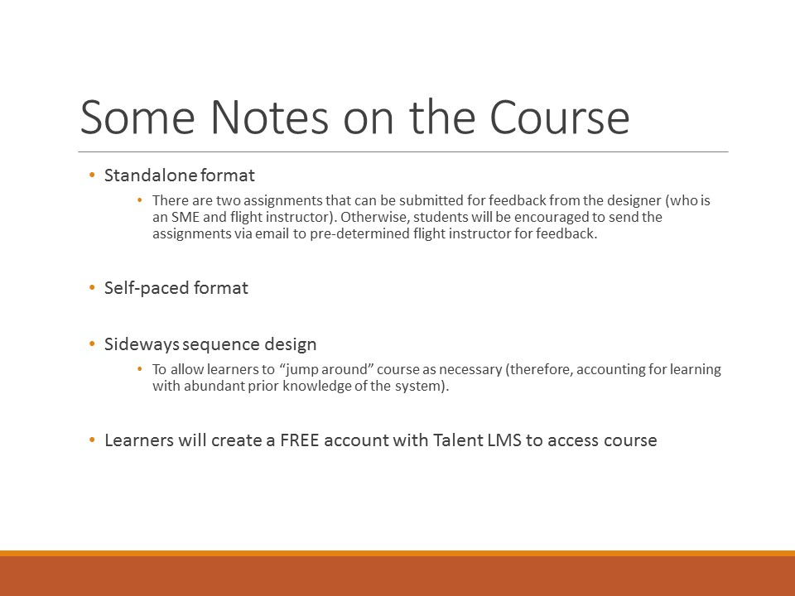

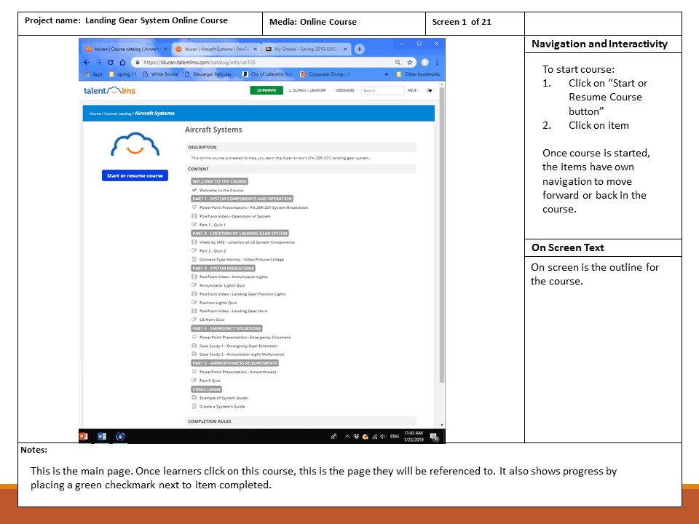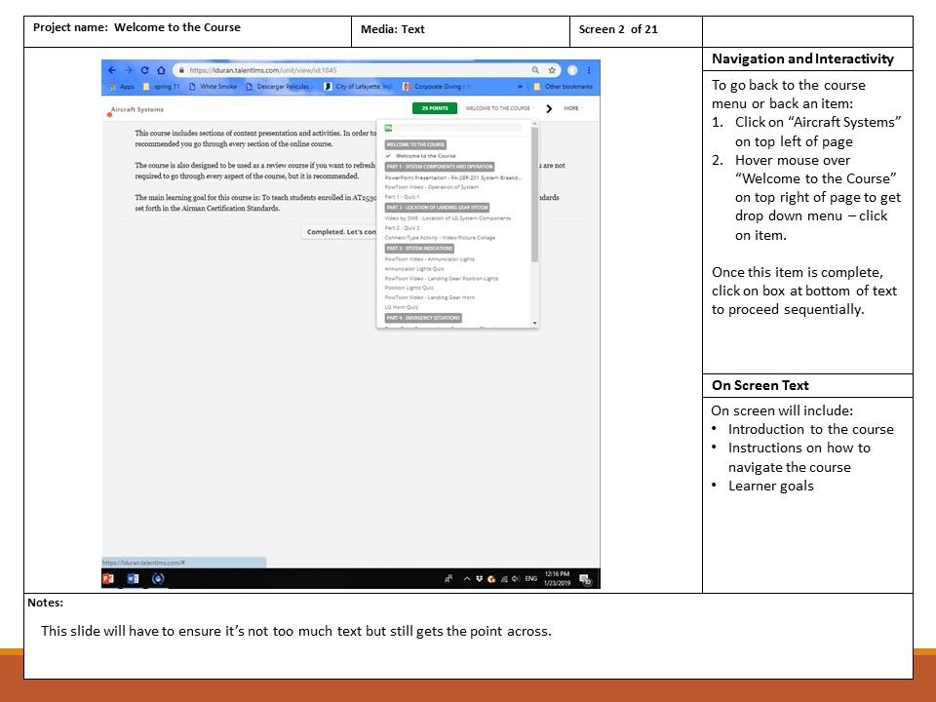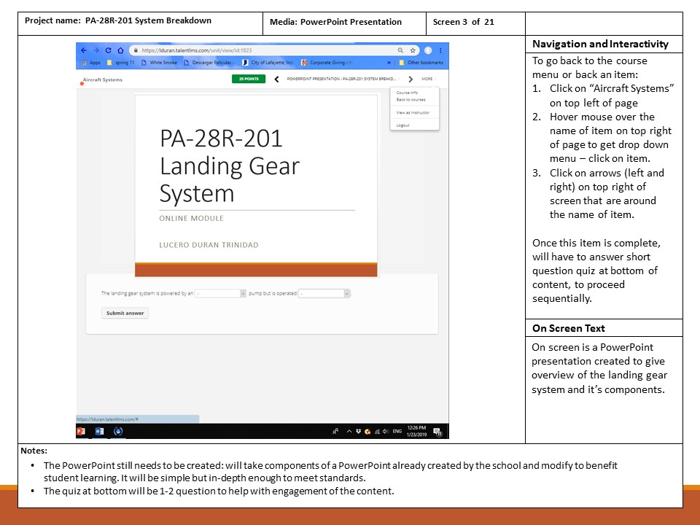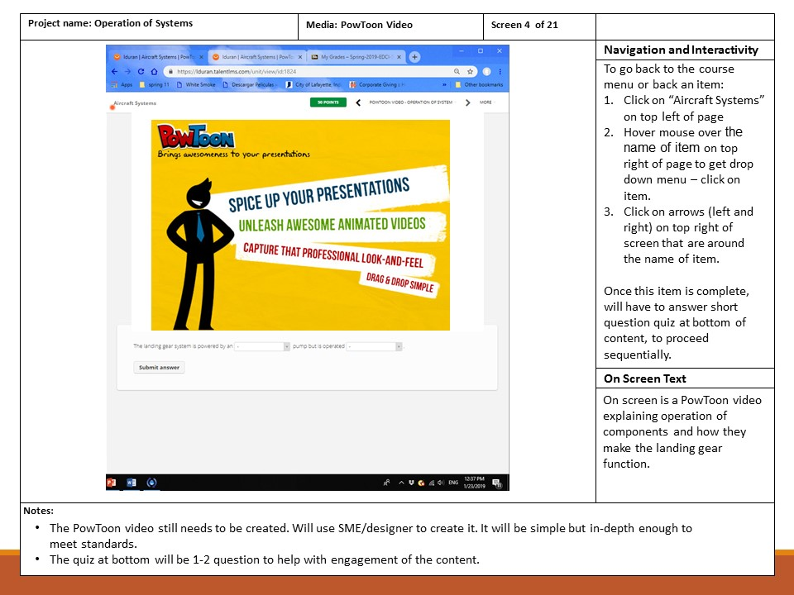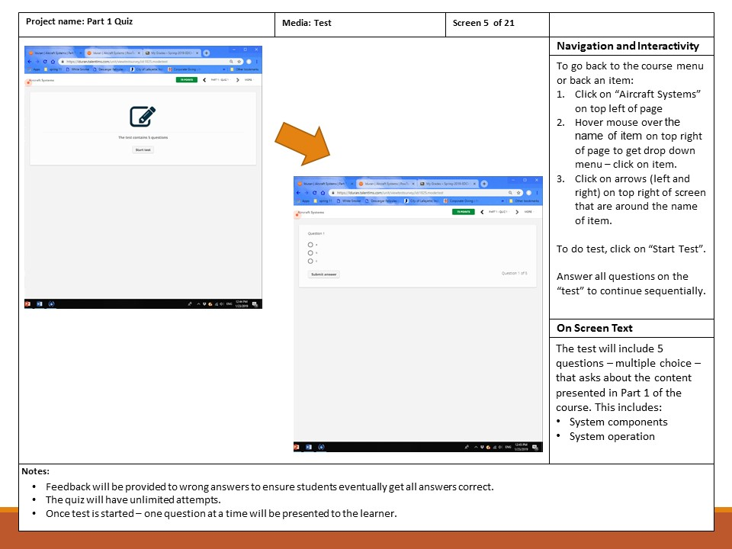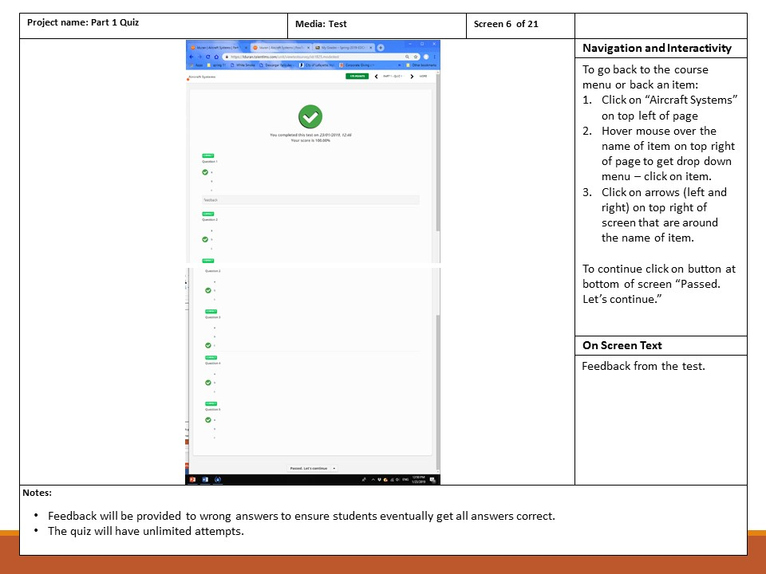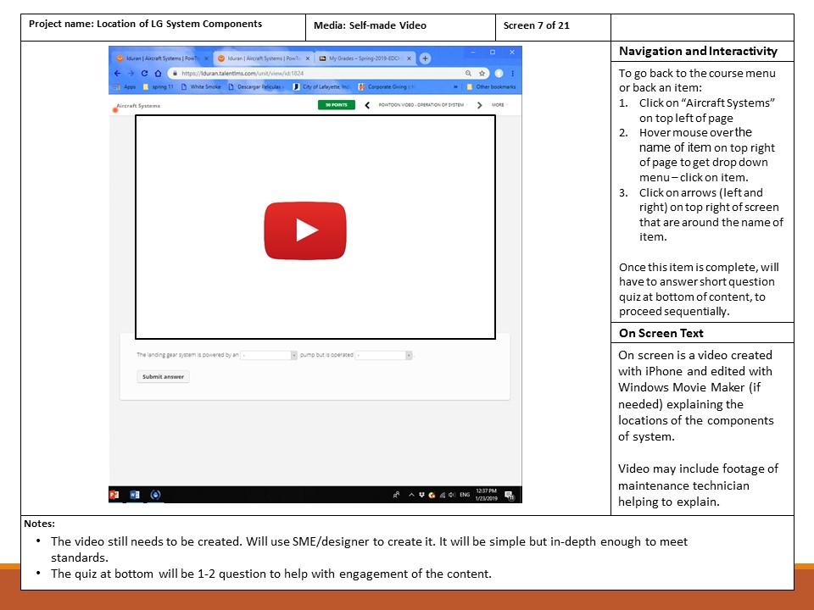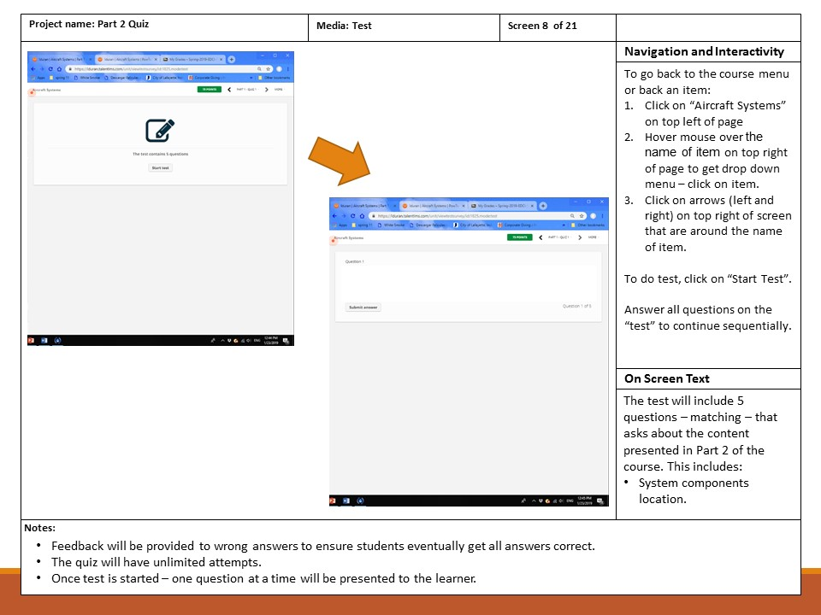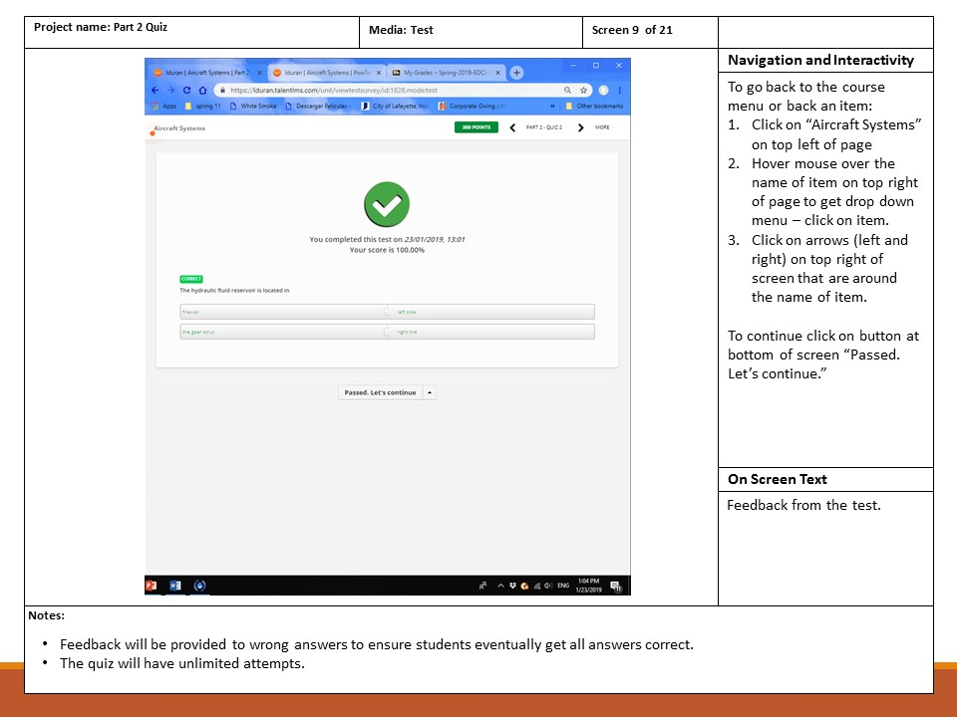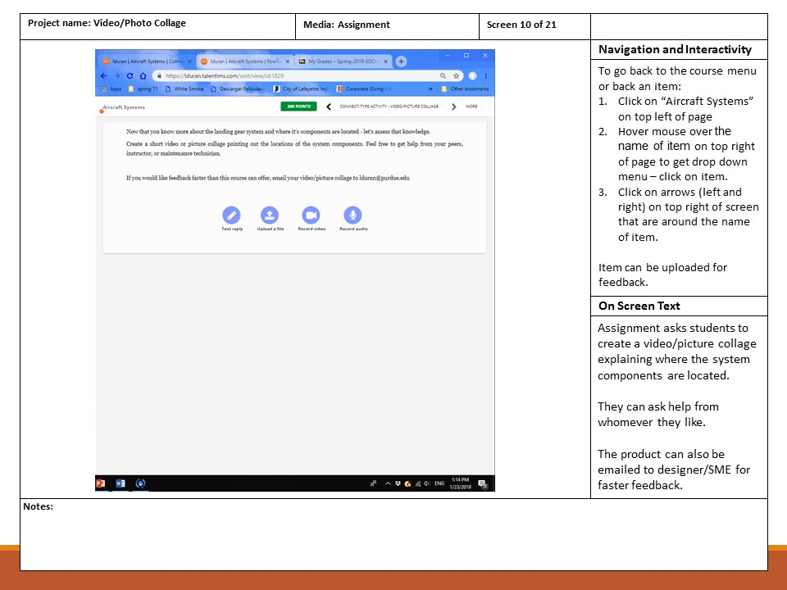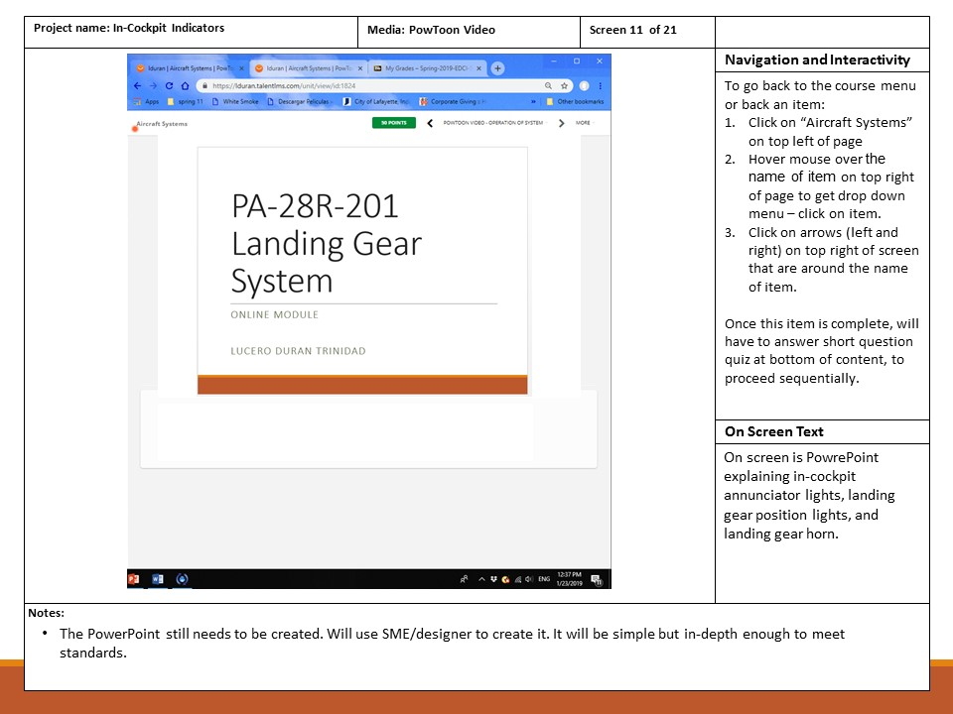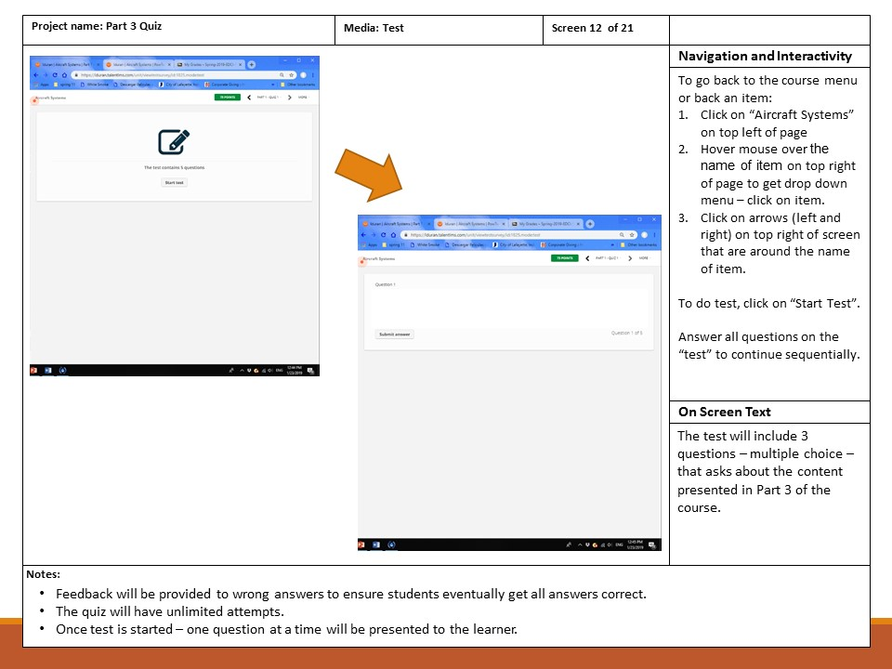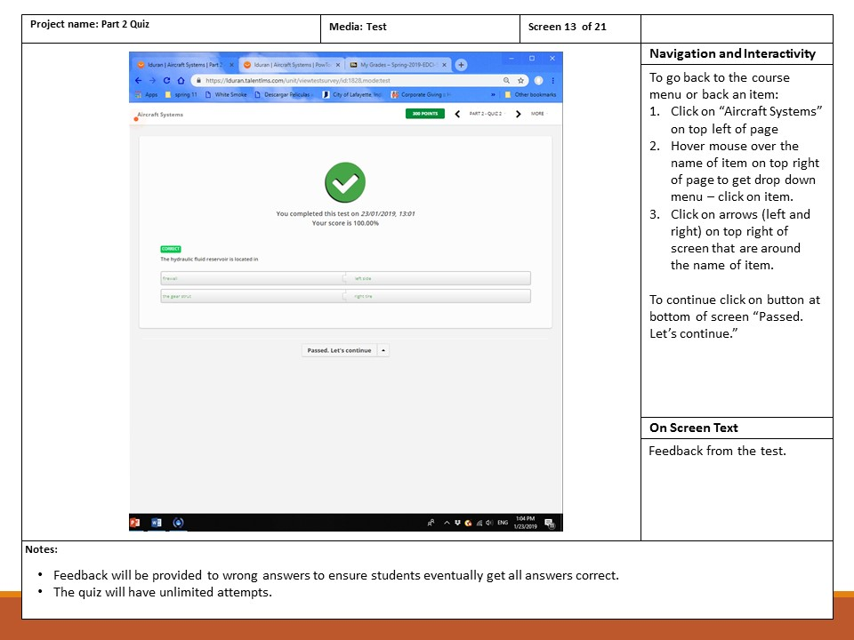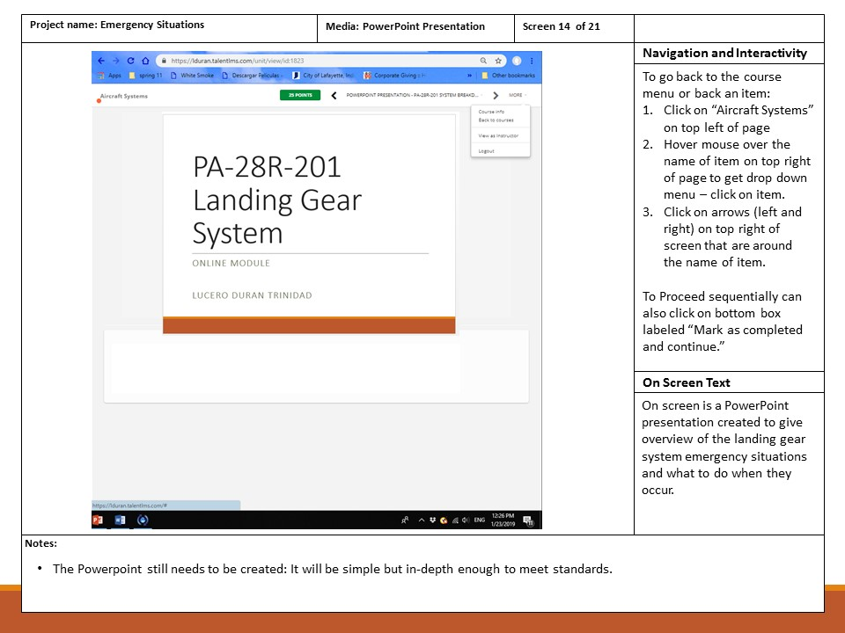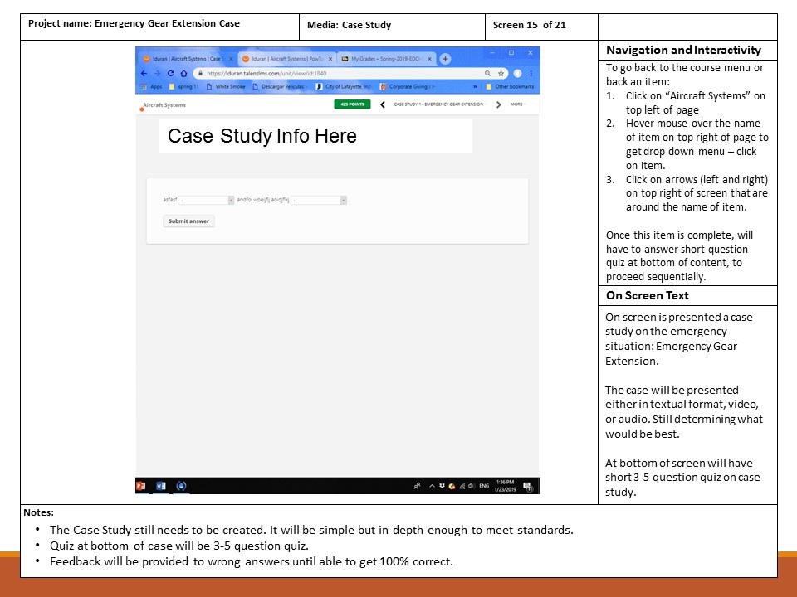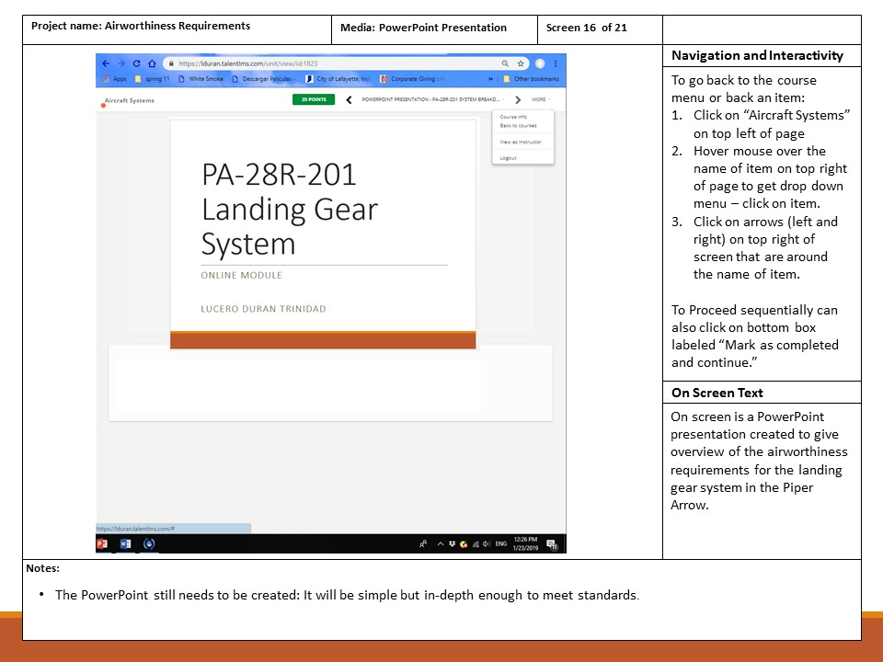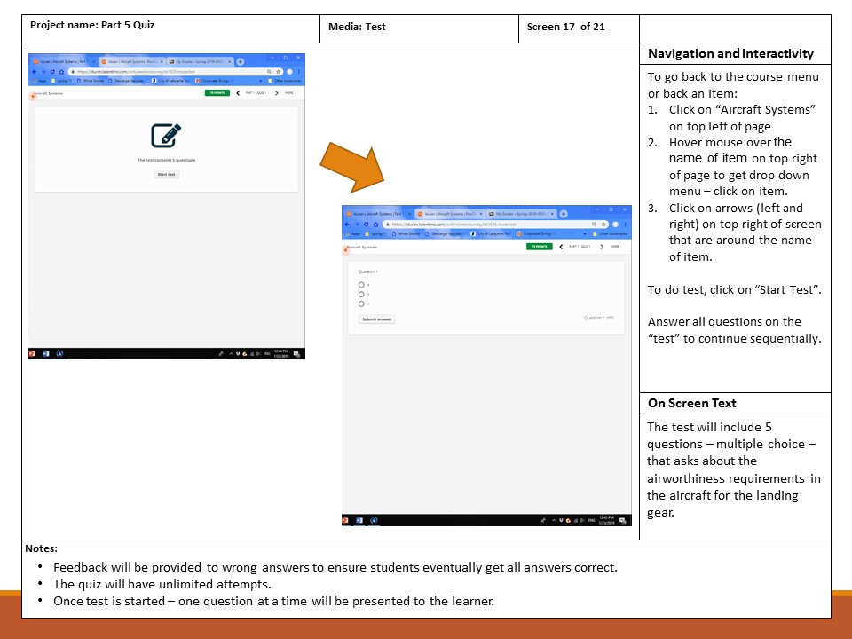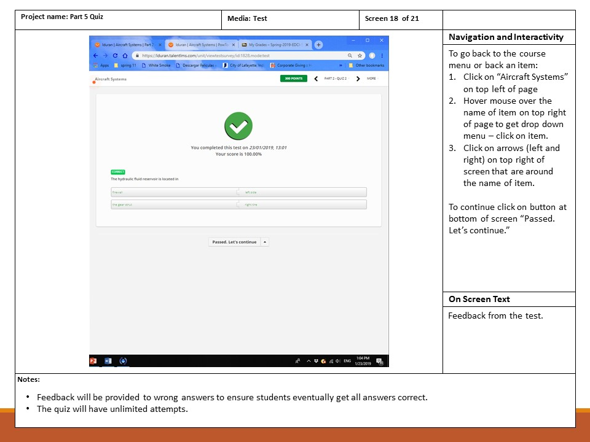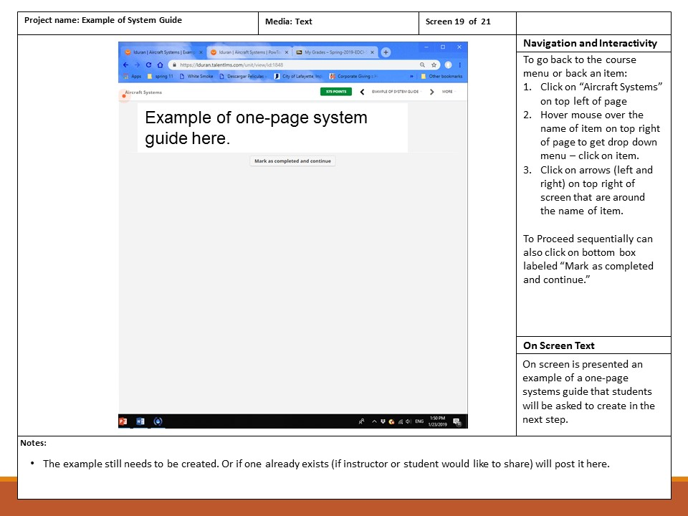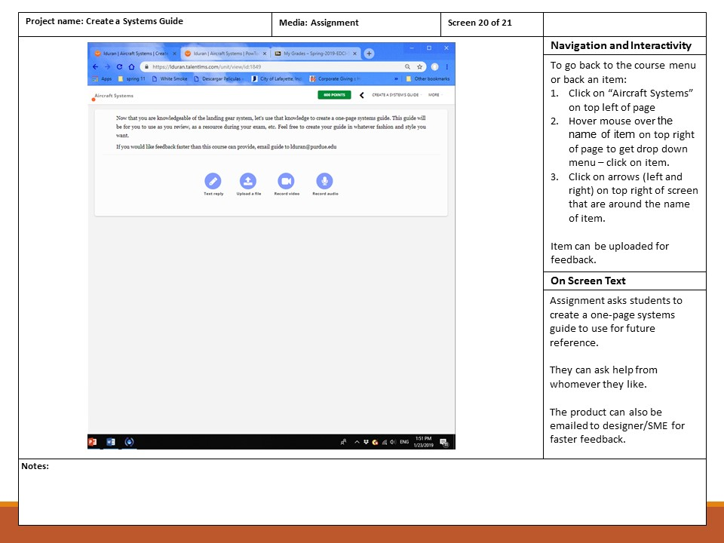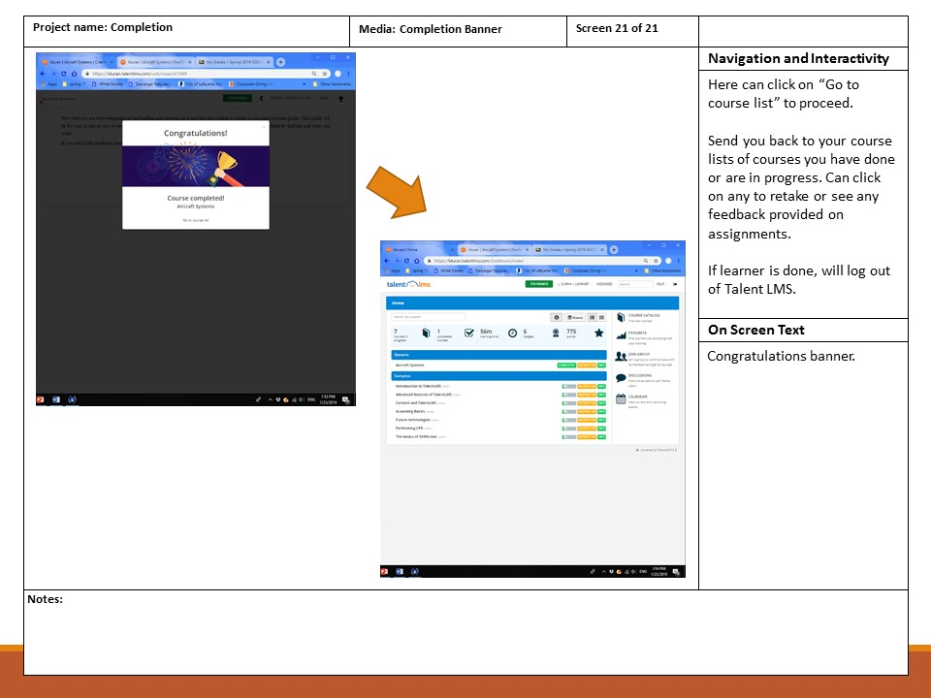

Appendix B
Course Instructional Material

Course Instructional Material

The following pages include the instructional material to be used in the course. This material will be uploaded to Talent LMS platform as is for the implementation of the course.

The instructional material is as follows.
Part 1 - This sections includes:
- PowerPoint presentation breaking down the landing gear system
- PowToon video explaining operation of landing gear system
Part 2 - This section includes:
- Video created by course designer describing location of landing gear system components
Part 3 - This section includes:
- PowerPoint presentation on the in cockpit indications related to the landing gear
Part 4 - This section includes:
- PowerPoint presentation on the emergency gear extension in Piper Arrow
- Case Study on the emergency situation
Part 5 - This section includes:
- PowerPoint on the airworthiness requirements for the landing gear system
Conclusion – This section includes:
- An example of an one-page systems guide

Part 1 Instructional Content: PowerPoint Presentation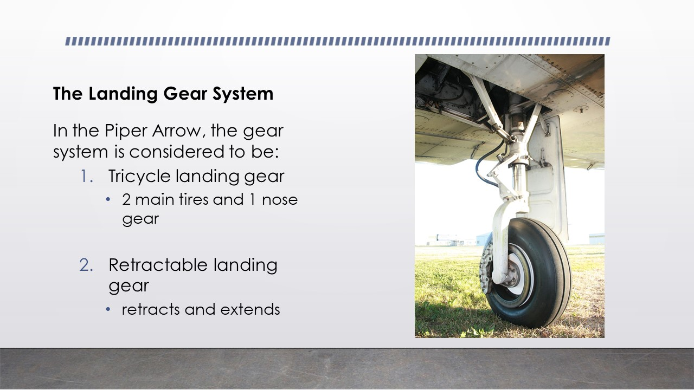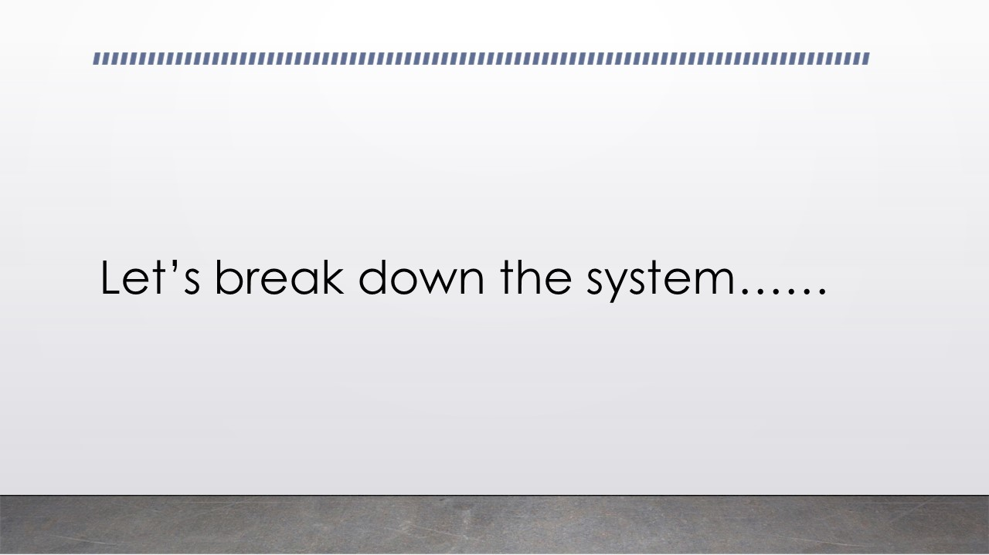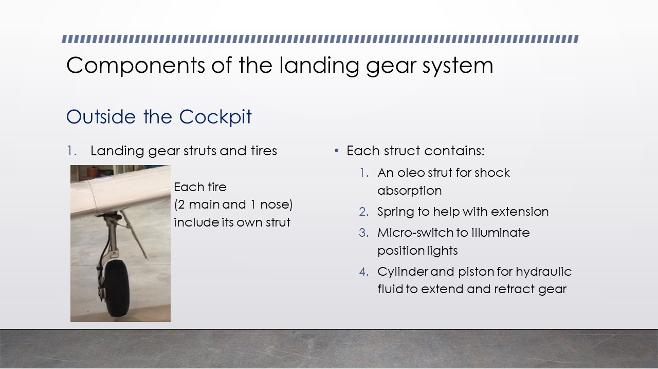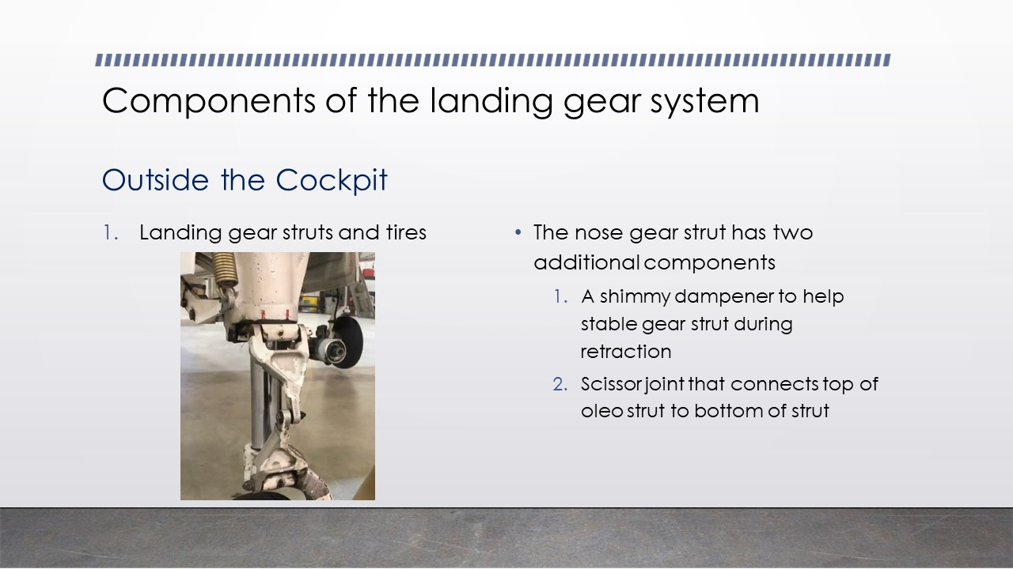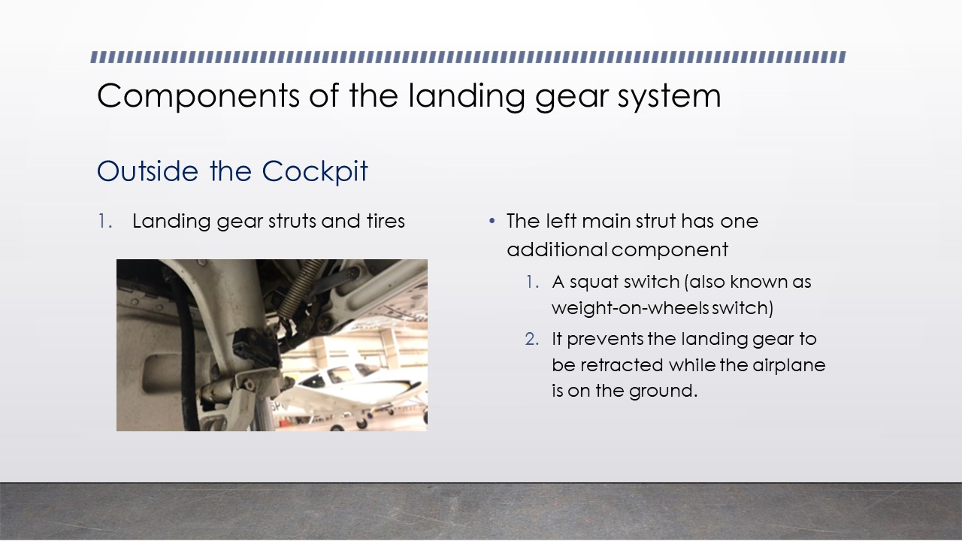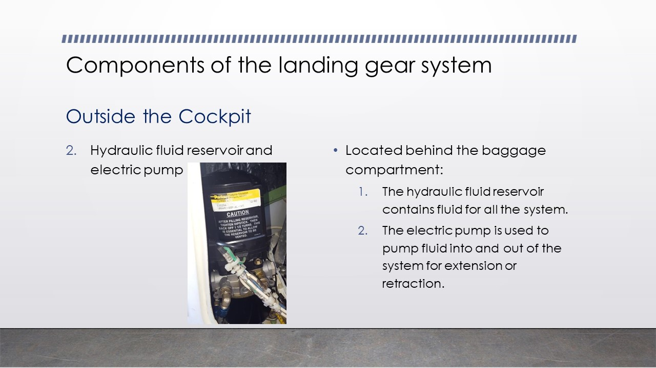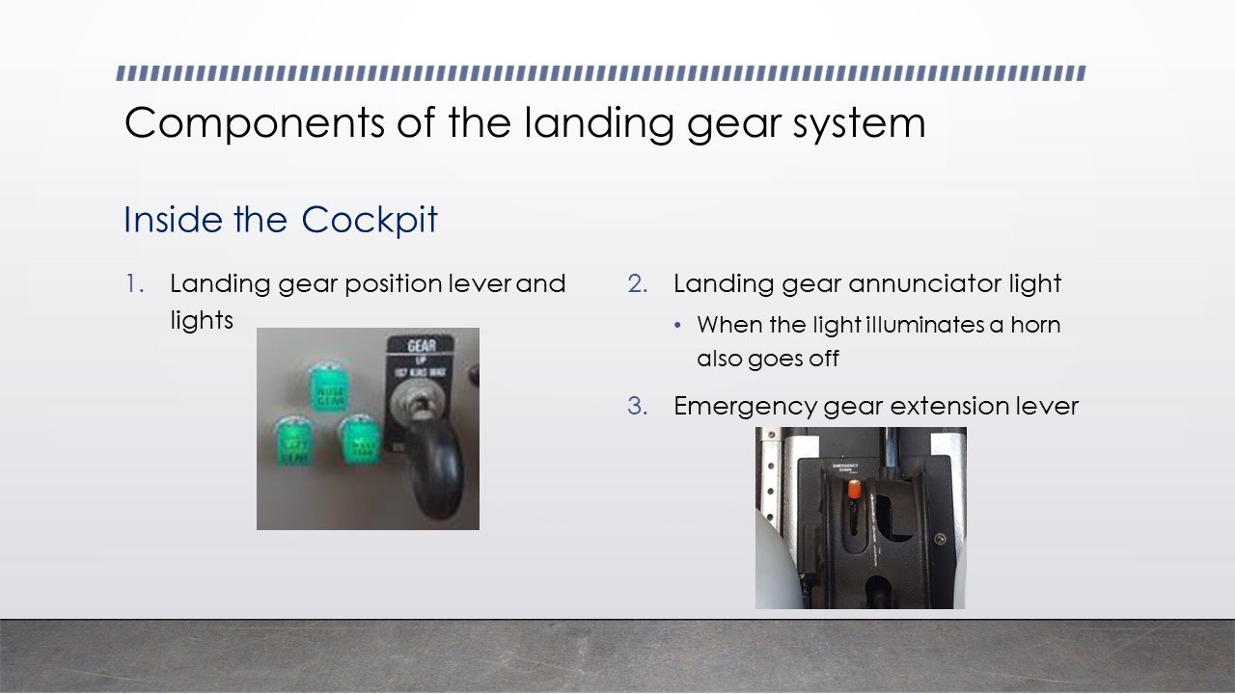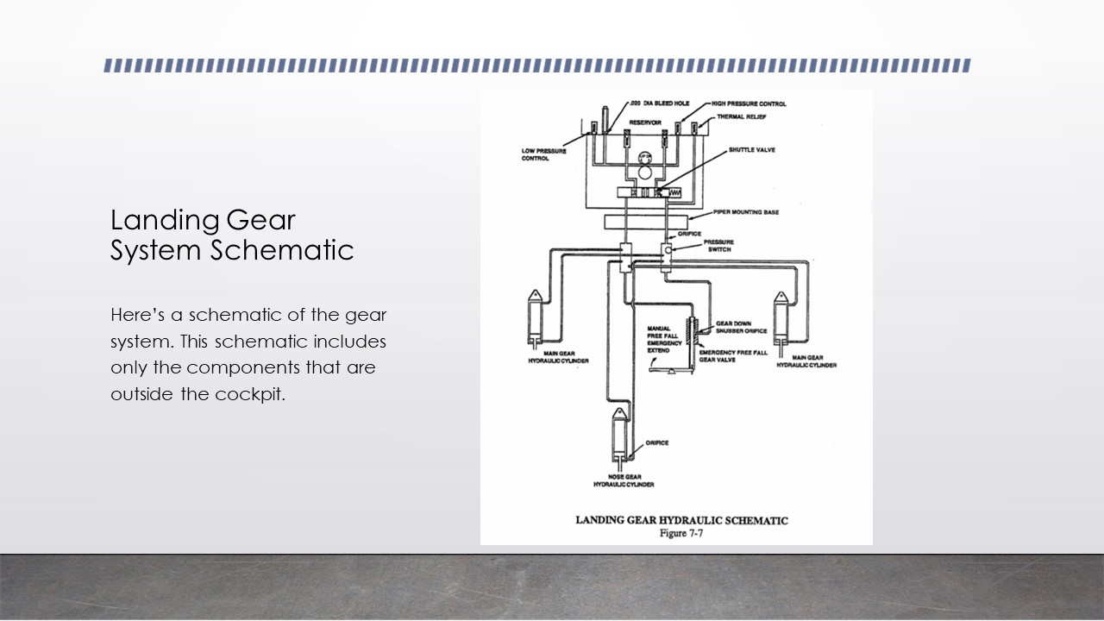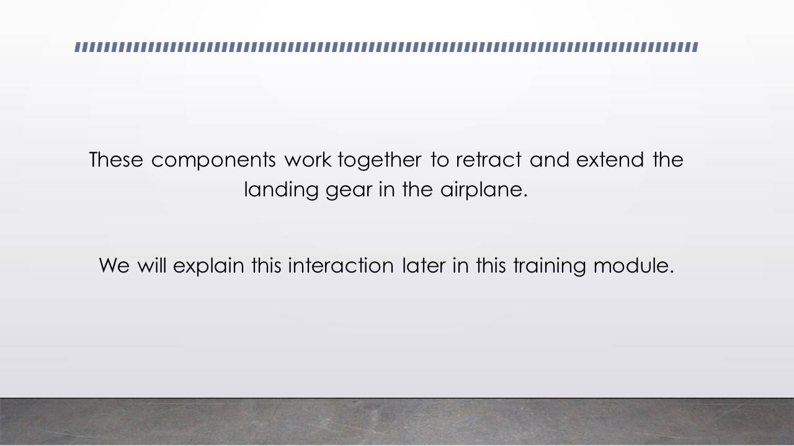
Part 1 Instructional Content: PowToon Video
The script for this animation video is below.
Table 4. PowToon Video Script
Slide | Content
1st slide | Graphics: Animated woman “talking” the following script.  Script:  “As you saw in the previous section of this course, the landing gear system is composed of various components that work together to operate the landing gear. Let’s get started!”
2nd slide | Graphics: Using a portion of the schematic of the landing gear system, will point out the hydraulic reservoir and electric pump.  Script:  “The landing gear system starts with the hydraulic reservoir, found behind the baggage compartment of the aircraft. The hydraulic reservoir includes all the fluid that will be used in the system.”  “Attached to the reservoir is the electric pump that will move the hydraulic fluid in and out of the reservoir for the retraction or extension of the gear. In order for the pump to operate, we need to ensure we have electrical power in the aircraft. If for some reason the electrical system fails, we will no longer have a pump to operate the landing gear.”
3rd slide | Graphics:  - Starts with an animation of the landing gear lever being moved to the down position as Script 1 is being played.  - A moving schematic of the system displaying the pump sending hydraulic fluid to the down chamber and the corresponding cylinders in each strut as Script 2 is being played.  - Change to picture of the gear down in position with no hydraulic fluid in the system as Script 3 is being played.  Script:  - “Let’s say we are coming in to land and we want to extend the gear. We would first set the landing gear lever inside the cockpit to the down position.”  - “This motion sends an electrical “signal” to the pump to start sending hydraulic fluid to the down chamber. The down chamber is pressurized to where now it will send the hydraulic fluid to each of the cylinders in the landing gear strut. This hydraulic fluid moves the piston inside the cylinders “down”, and since they are attached to the strut, bringing the gear down.”  - Once the gear strut is in the down position, it is held in place with mechanical locks. The locks are attached with micro-switches that close the circuit and electricity is able to flow to the position lights inside the cockpit, thus turning ON. As you can see, no fluid pressure is kept as the mechanical locks and springs on each strut keep the gear down.”
4th slide | Graphics:  - Starts with an animation of the landing gear lever being moved to the up position as Script 1 is being played.  - A moving schematic of the system displaying the pump sending hydraulic fluid to the up chamber and the corresponding cylinders in each strut as Script 2 is being played.  - Change to picture of the gear in up position with hydraulic fluid in the system as Script 3 is being played.  Script:  - “Now let’s see how the system works when we bring the gear up. Again we start by setting the landing gear lever inside the cockpit to the up position. At this point the position lights turn OFF and the struts start retracting.”  - “Now an electrical “signal” is sent to the pump to start sending hydraulic fluid to the up chamber. The up chamber is pressurized, the down chamber is depressurized, and hydraulic fluid is sent to the cylinders via another hydraulic line. The hydraulic fluid moves the piston inside the cylinders “up”, and since they are attached to the strut, bringing the gear into the up position.”  - Once the gear strut is in the up position, it is held in place with hydraulic fluid. This is why you see the schematic maintain its color to show that there is hydraulic pressure on the lines. If there was no hydraulic pressure, the gear would start to fall down into the down position due to gravity.
5th slide | Graphics:  - Will start with picture of the emergency gear extension lever as Script 1 is being played.  - Change to schematic motion showing the valve opening and hydraulic fluid sent back to the reservoir. Also, the schematic will show the pistons in cylinders moving “down” as Script 2 is being played.  - Picture of the gear in down position as Script 3 is being played.  Script:  - “Now that we know how the gear system operates under normal circumstances, let’s talk about the emergency gear extension. The emergency gear extension exists just in case the electric pump fails and we are not able to decrease the hydraulic pressure in the system to let the gear down.”  - In order to bring the gear down we would have to lower the emergency gear extension lever. This motion opens a valve in the hydraulic lines that send all the pressurized fluid back to the reservoir. This “depressurization” of the system, allows the pistons in each cylinder strut to move “down” due to gravity.”  - “Once the struts reach the down position, they will stay there due to the mechanical locks and springs. Now, because we opened a valve in the system, after we use the emergency gear extension, we will not be able to retract the landing gear. Therefore, make sure you are prepared to fly with the gear in the down position until you are able to get on the ground.”
6th slide | Graphic: Animated woman “talking” the following script.  Script:  “Let’s do some review! The landing gear system uses an electrical pump that moves hydraulic fluid to and from the reservoir depending on whether we are extending or retracting the gear.”  “When extending the gear, we are using hydraulic fluid to “push down” the piston in each strut’s cylinder to send the strut to the down position. The strut stays in place due to mechanical locks and springs.”  “When retracting the gear, we are instead sending the pistons in each cylinder “up”, bringing the gear struts into the up positions. The landing gear then stay in the up position due to the pressurization of hydraulic fluid in the system.”  “If we ever have an issue with the pump or a leak in the system, the gear will either fall to down position due to gravity or we would use the emergency gear extension.”  “If you have any further questions regarding the operation of the landing gear system, reference the POH section 7.”

Part 2 Instructional Content: SME Video
The video created for this section of the course can be found at: https://drive.google.com/open?id=1NK5-tS_o2i8_pJ4CO-GGeg8QQtmW-8PH

Part 3 Instructional Content: PowerPoint Presentation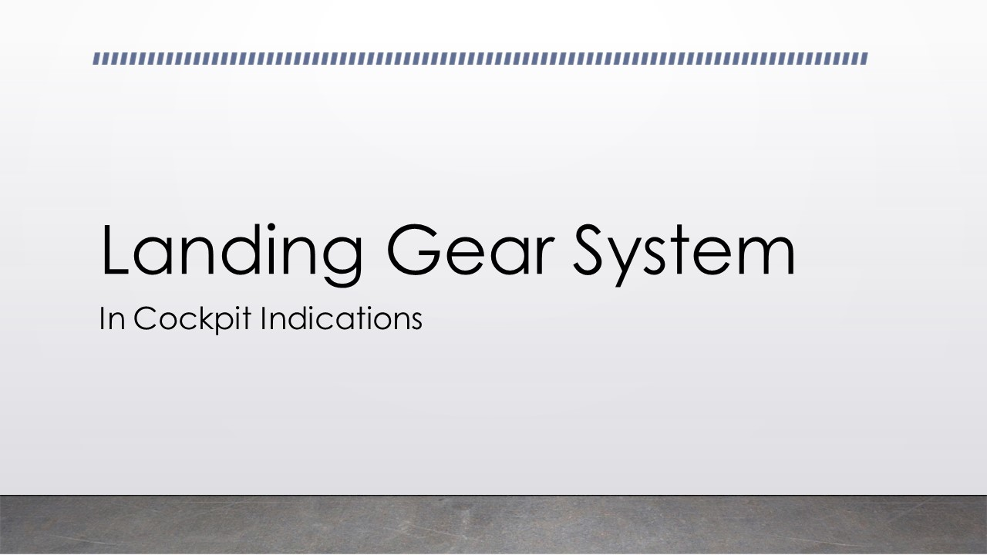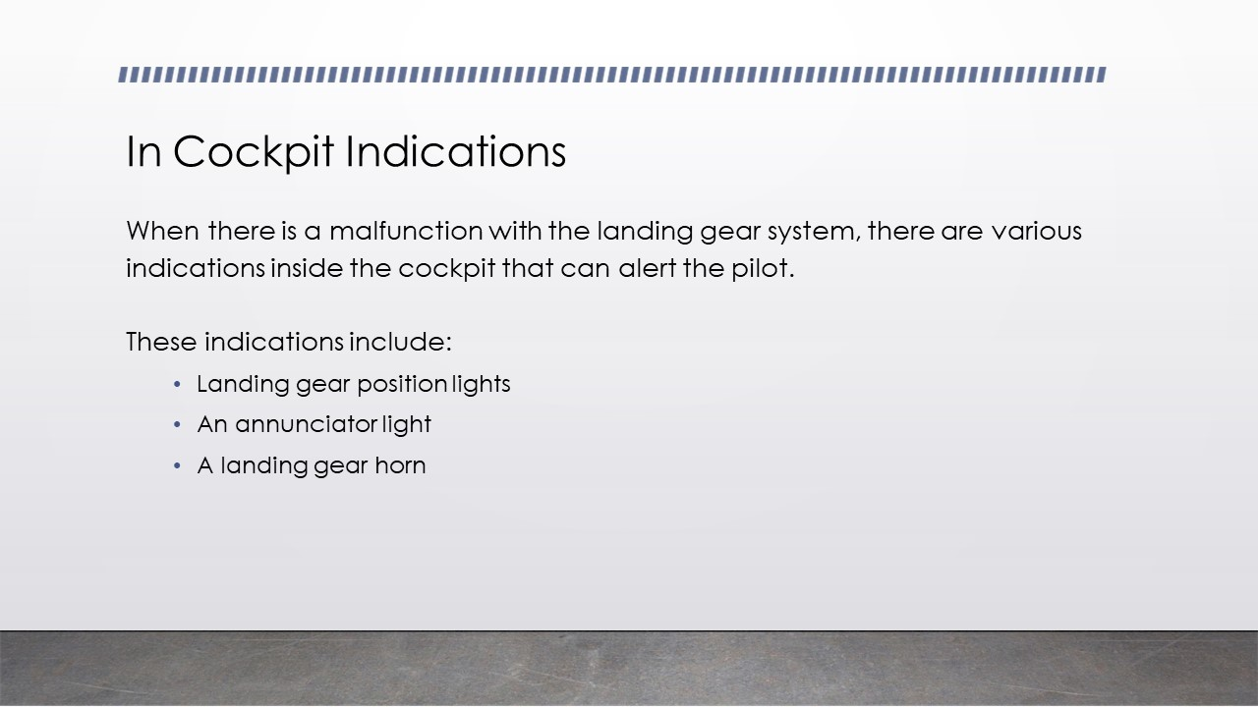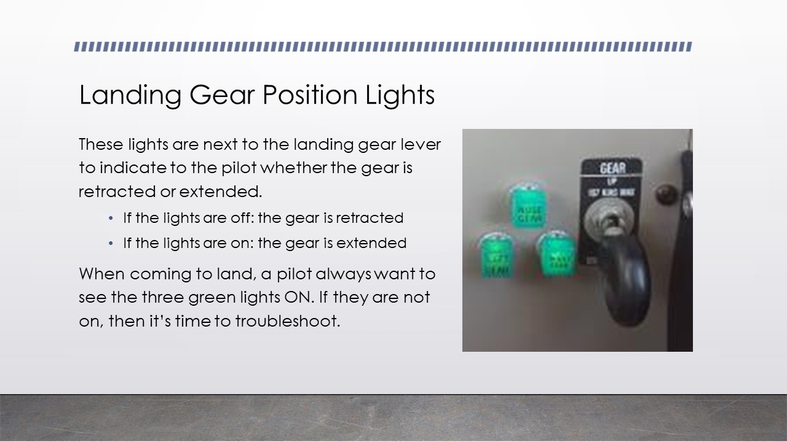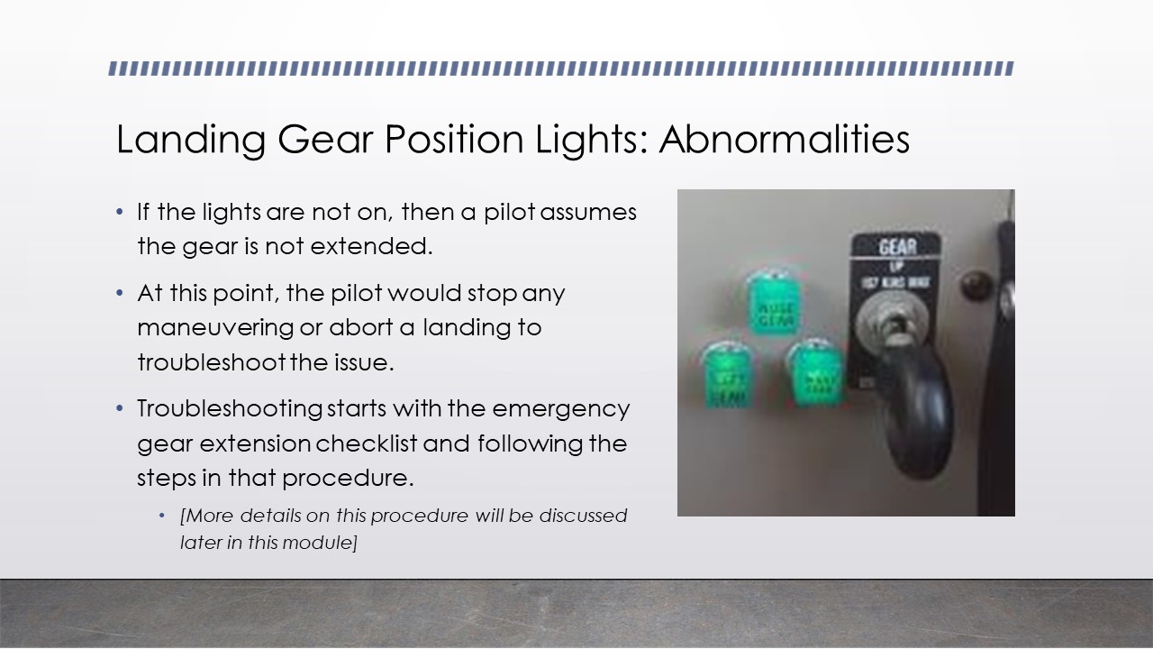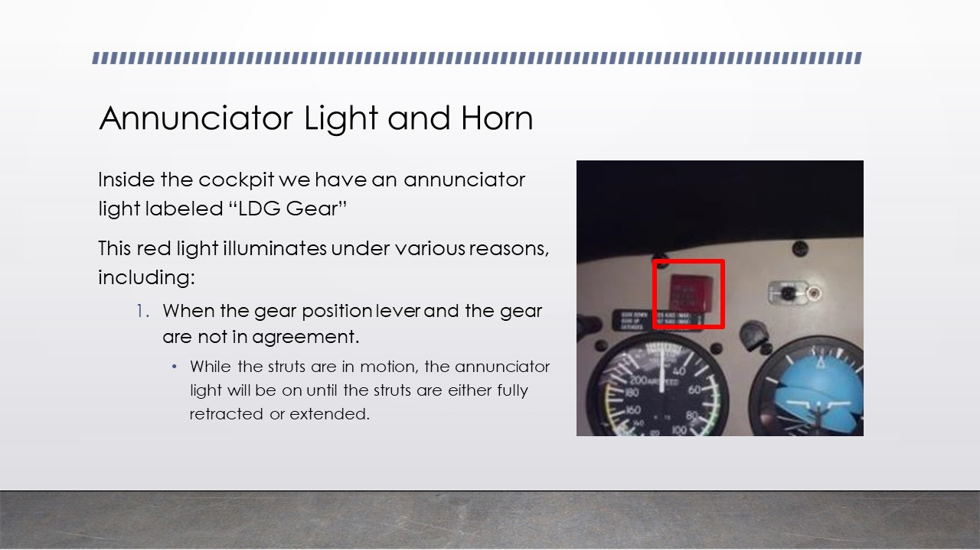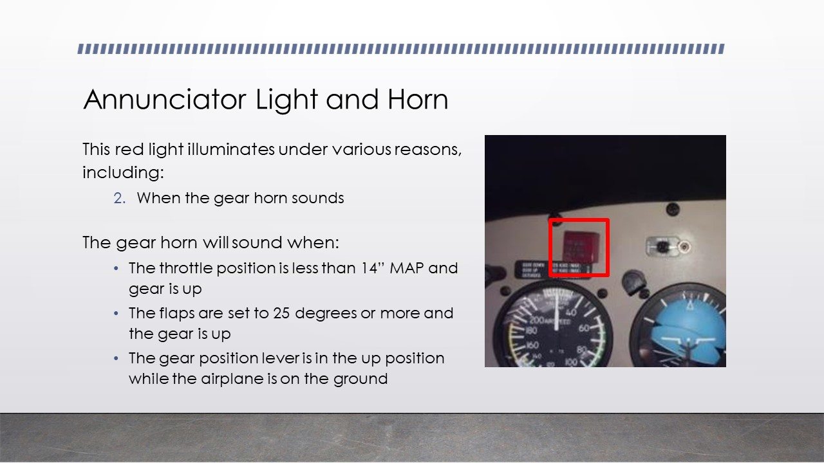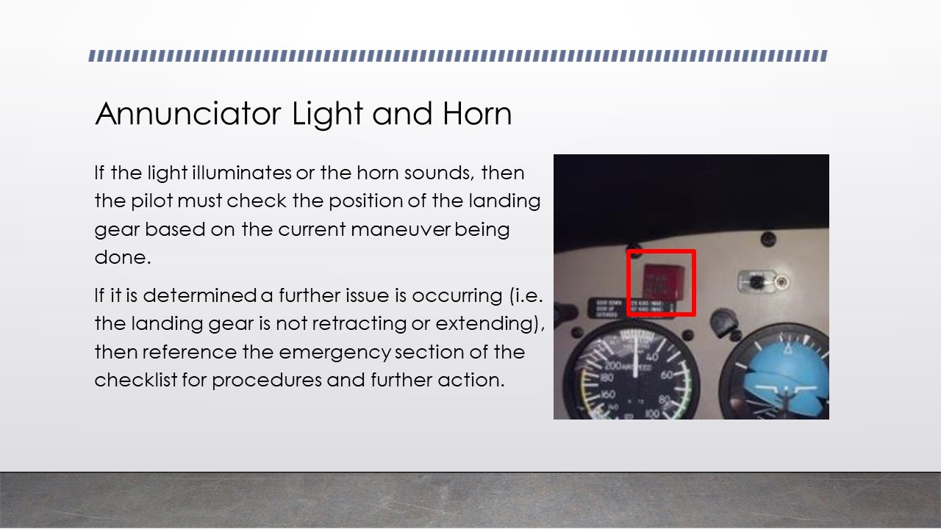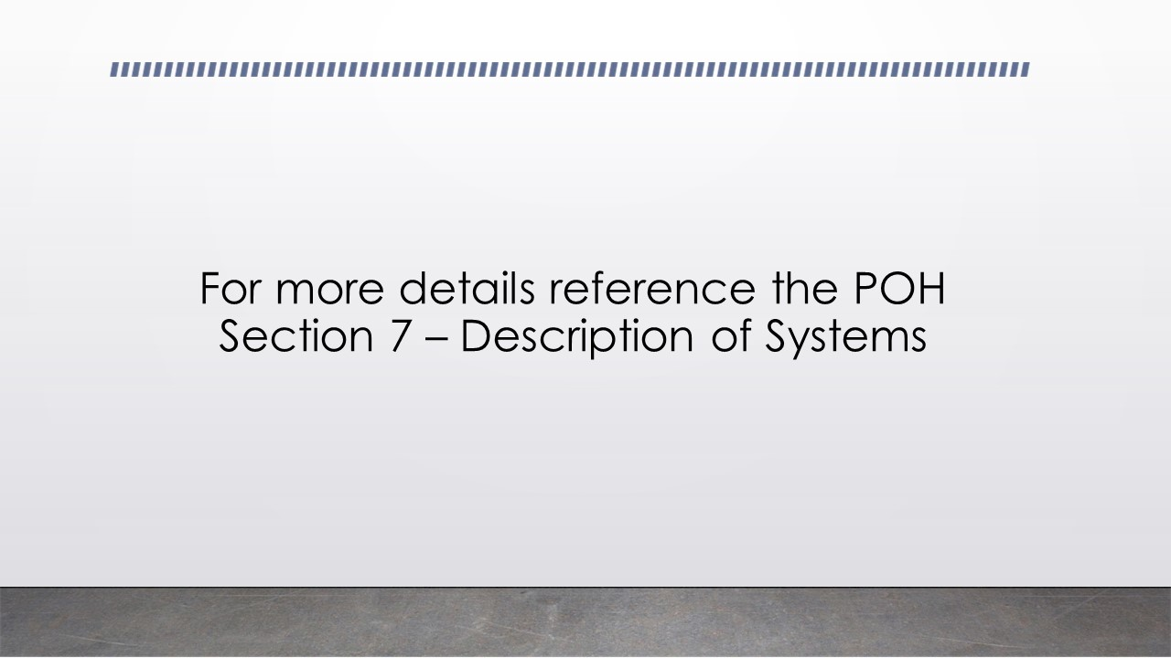
Part 4 Instructional Content: PowerPoint Presentation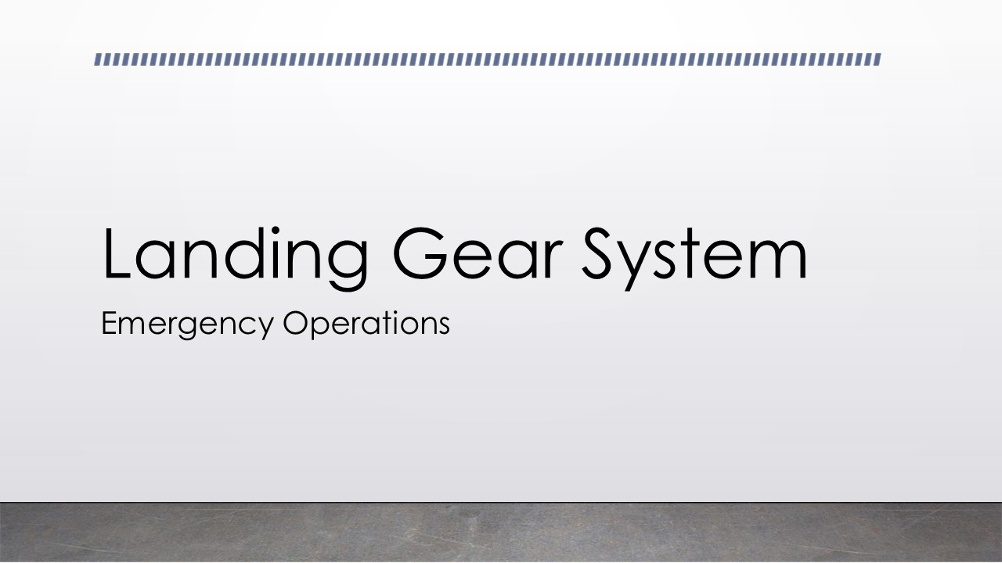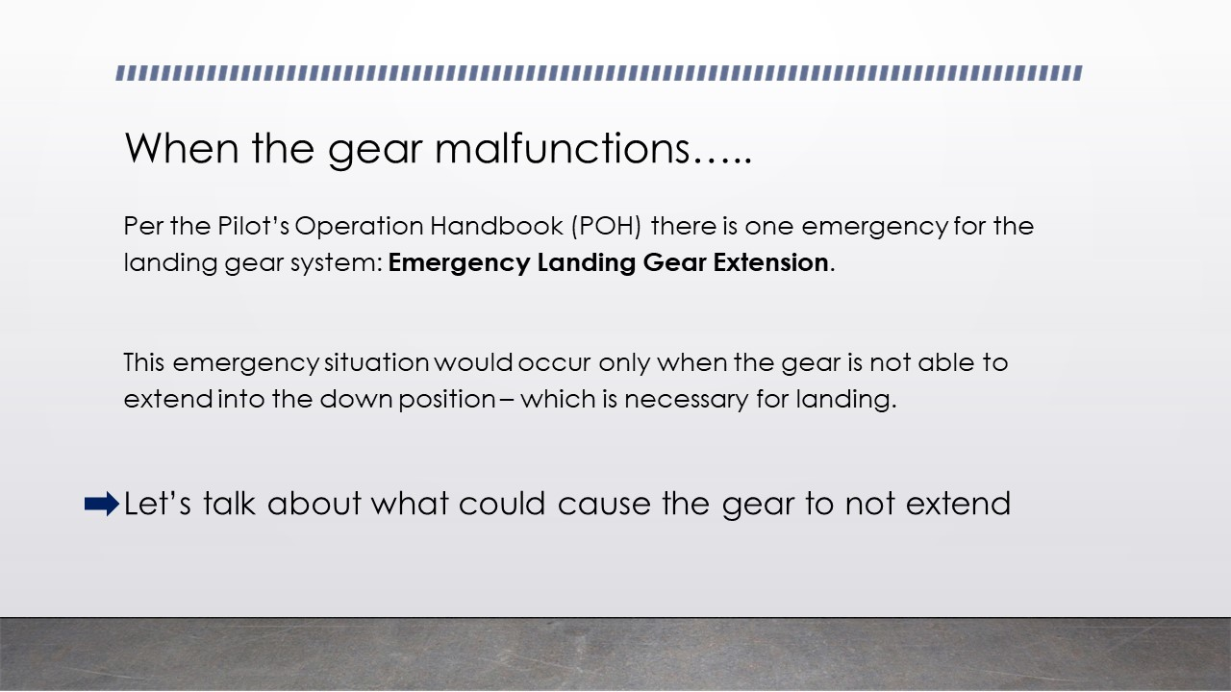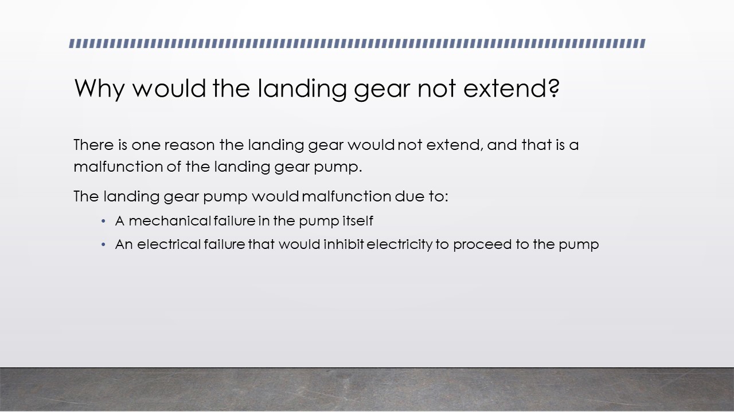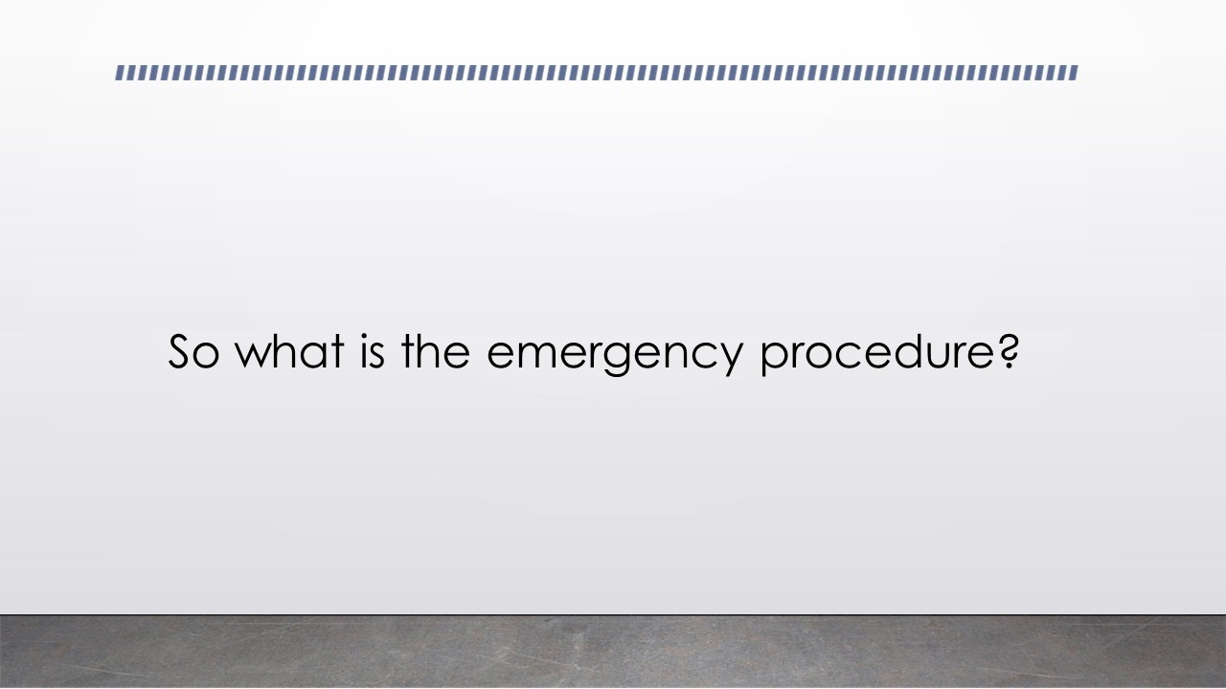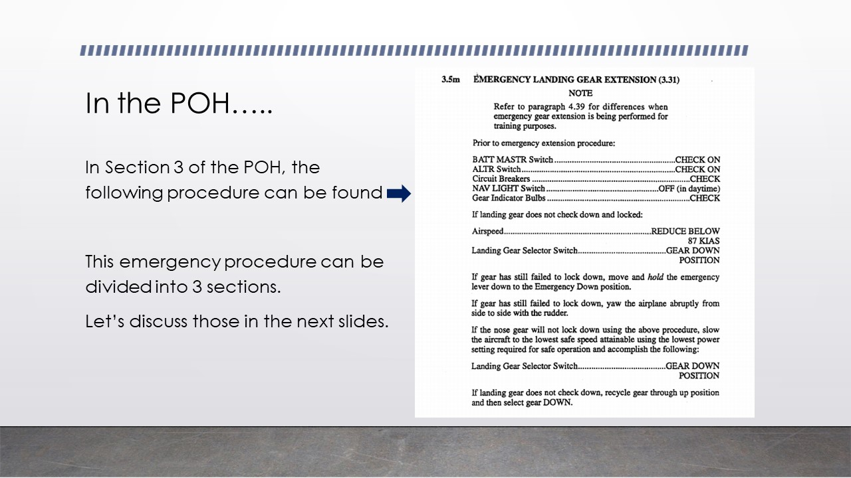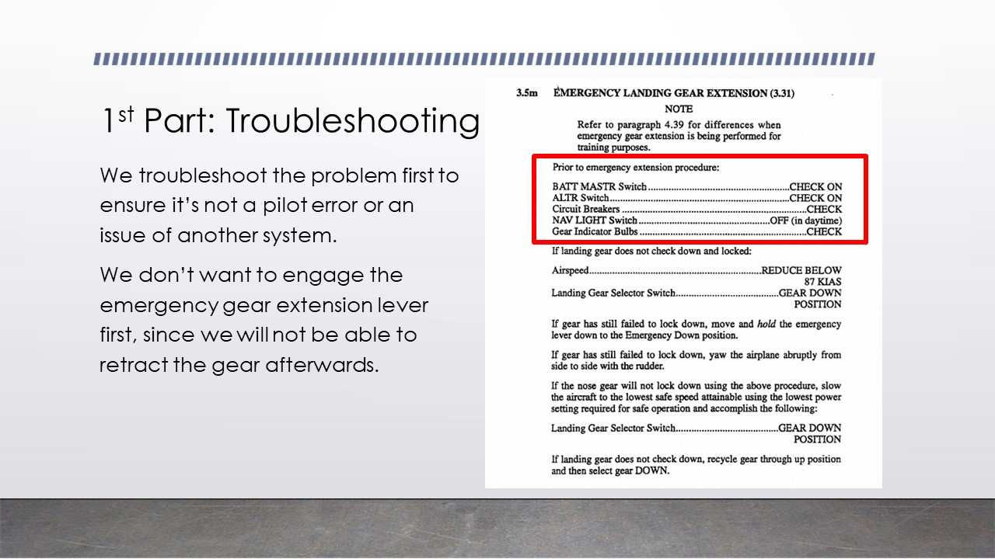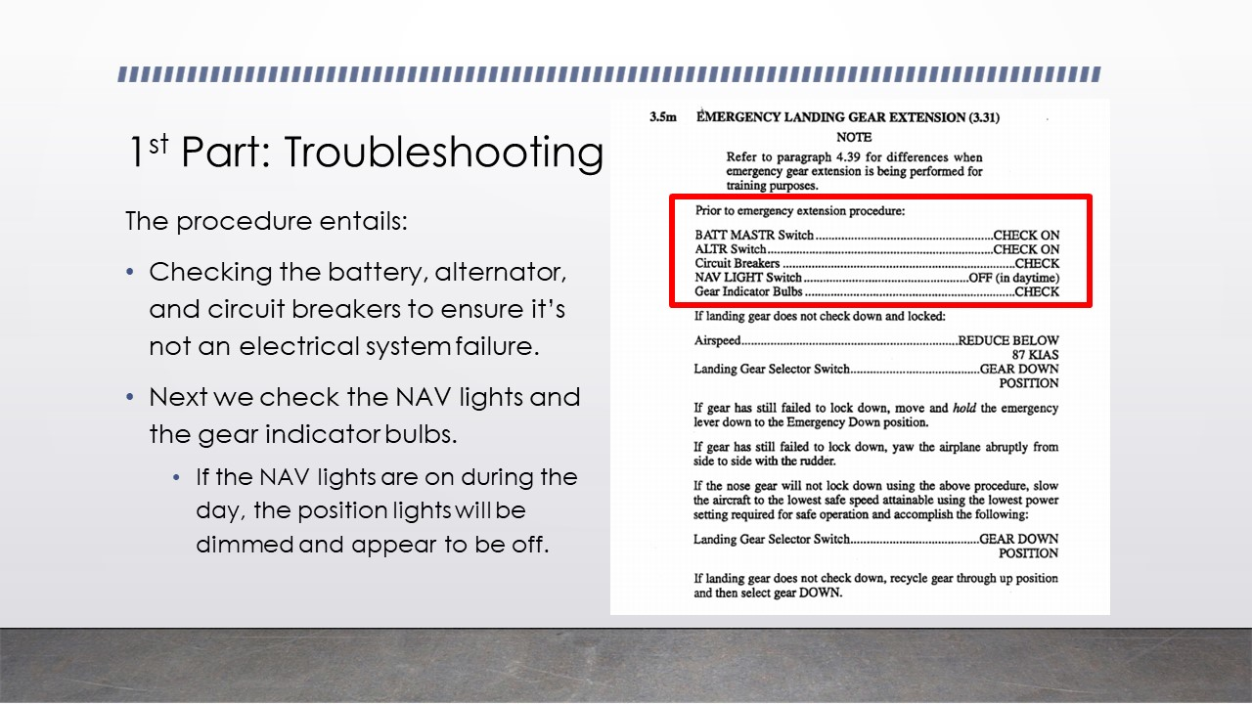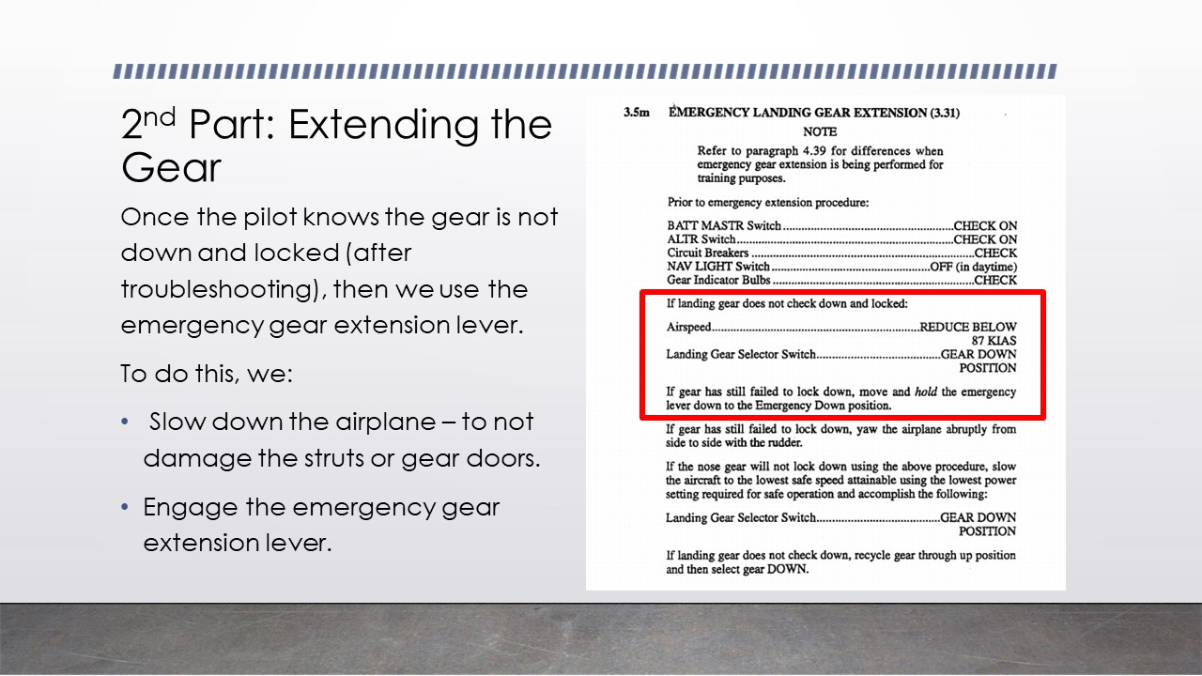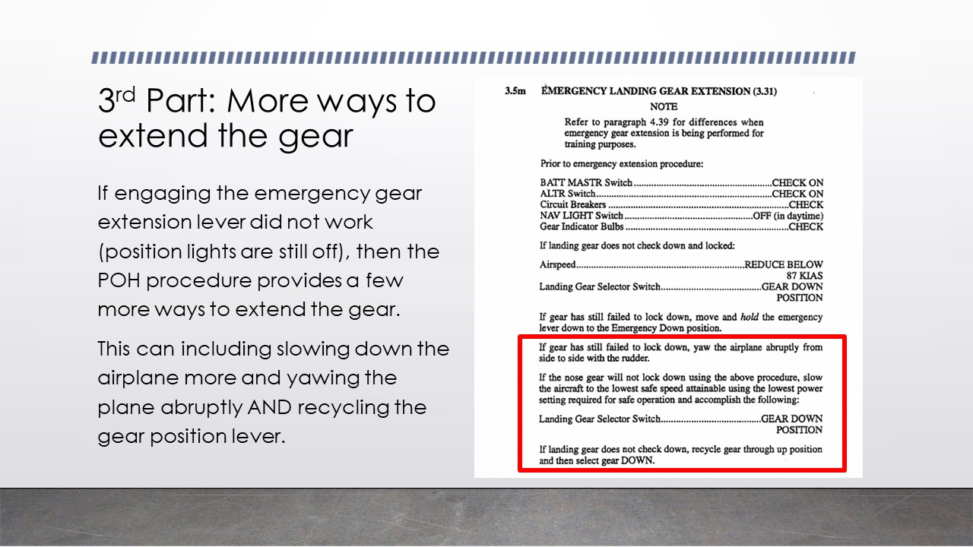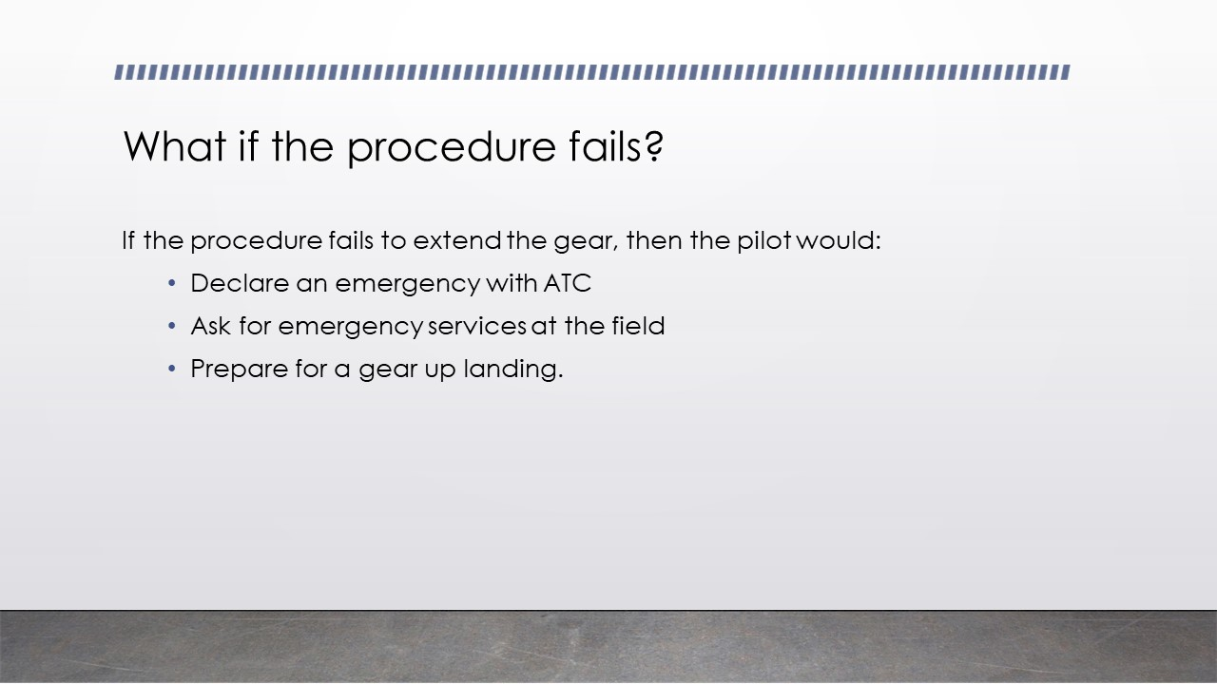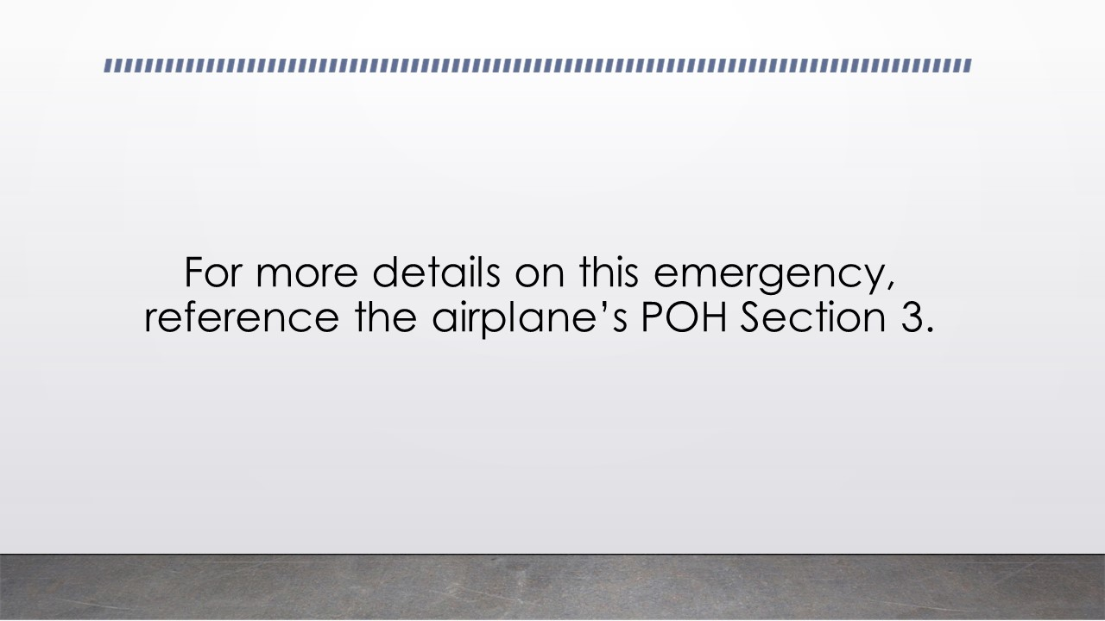
Part 4 Instructional Content: Case Study
The following case study will be presented to the learners. Afterwards, they will be asked to answer a few questions.

You and your instructor are out in the practice area practicing various maneuvers to prepare for your checkride. Some of this maneuvers include slow flight, stalls, commercial maneuvers, and emergencies. As you are finishing up the lesson, your instructor asks you to do slow flight one more time. After clearing the area, you start the procedure by bringing the throttle back and slowing down. When you notice the airspeed slow below the gear extension limit, you grab the gear position lever and put it in the down position. After a few seconds, you and your instructor notice the three green lights have not turned on, indicating to both of you that the gear might not be in the down position. At this point, you stop the maneuver and decide to deal with this issue.
Answer the following questions based on the information presented in the PowerPoint in last section and this scenario.
- What are the first steps you should take to deal with this issue?
  - Continue with the maneuver, recover, and then grab the emergency gear extension checklist.
  - Stop the maneuver and grab the emergency gear extension checklist *
  - Stop the maneuver and pull the emergency gear extension lever
- On the emergency gear extension checklist, why does it asks us to slow down prior to engaging the emergency gear extension lever?
  - To reduce damage on the struts and gear doors when free-falling *
  - To make the aircraft easier to fly while doing the checklist
  - To ensure you will not hit other aircraft since you are not flying that fast
- When we engage the emergency gear extension lever, are we able to bring the gear up?
  - No, we have released the hydraulic fluid in the system by opening a release valve.*
  - Yes, the gear came down due to gravity, but our electric pump still works.

Part 5 Instructional Content: PowerPoint Presentation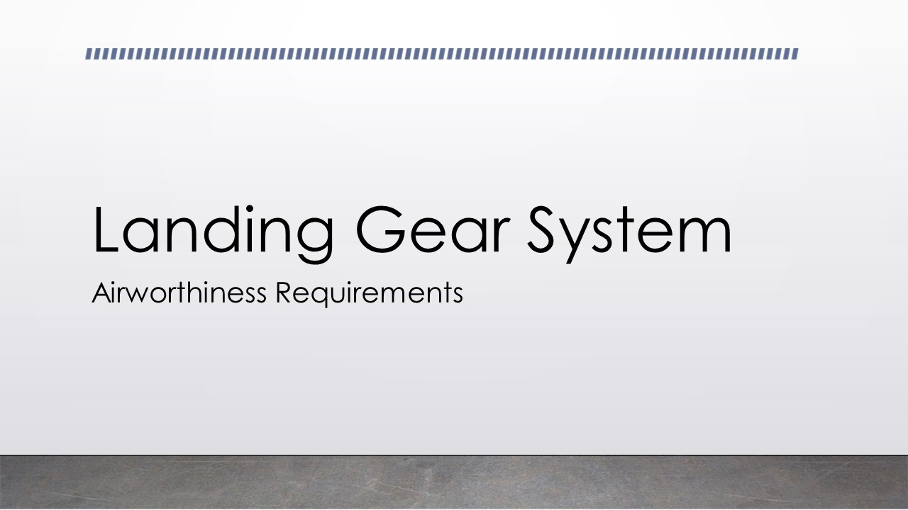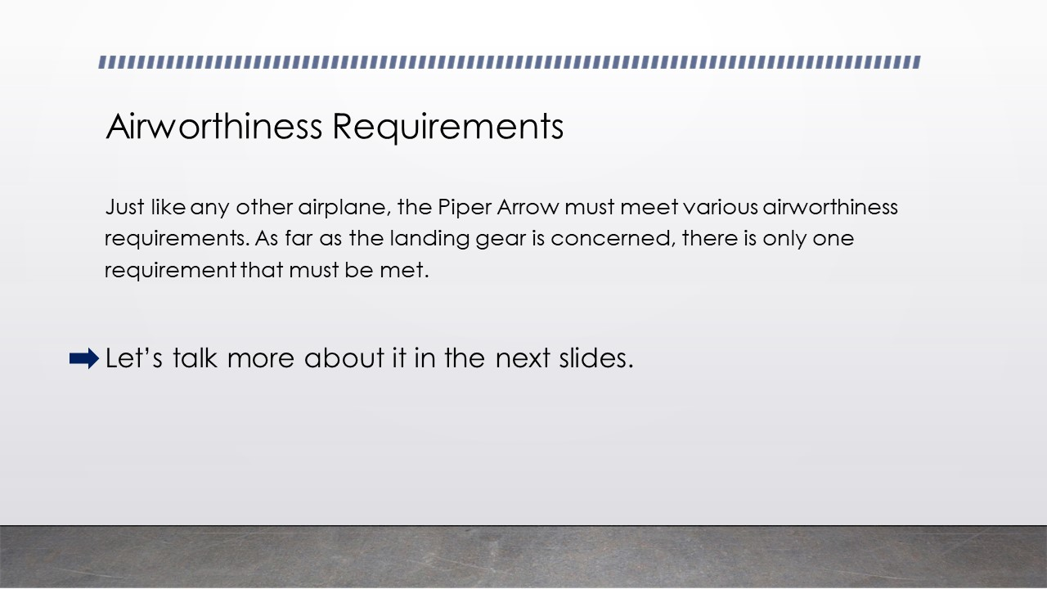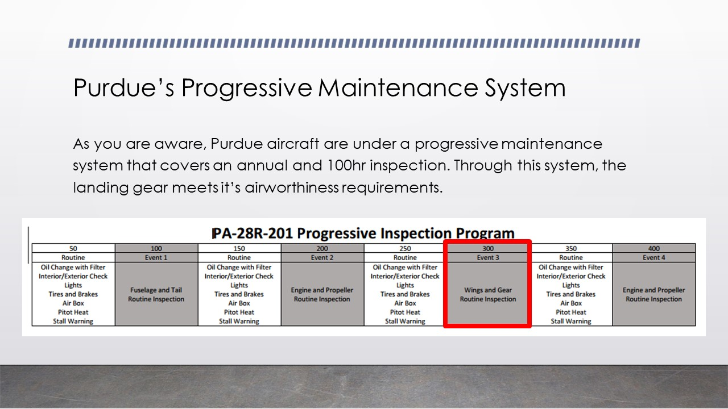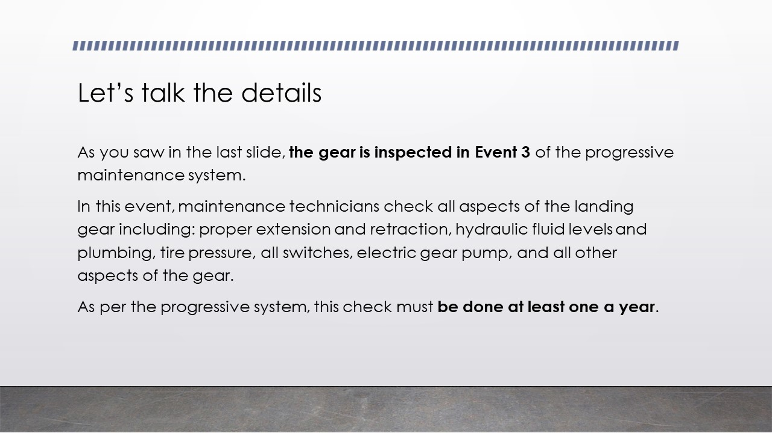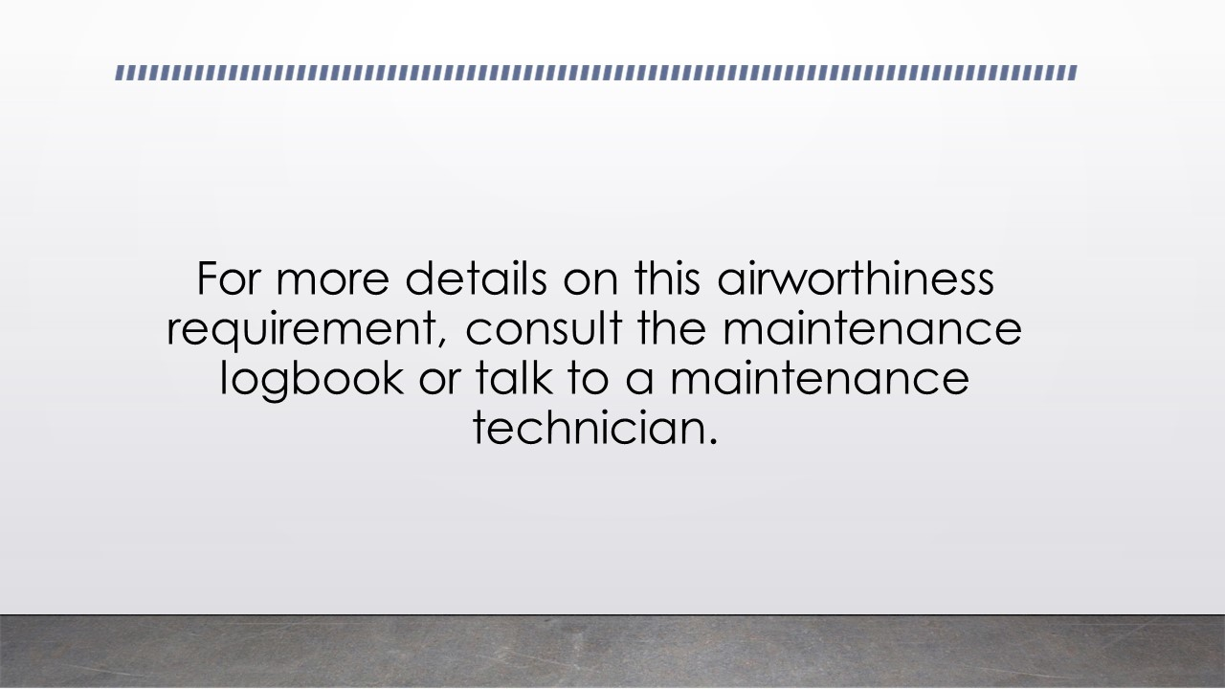

Conclusion Instruction Content: One Page Systems Guide
The following is an example of a simple systems guide for a specific system in an aircraft. Although this example is not of the Piper Arrow, it serves as an example of what a systems guide could look like for the landing gear system.
Student Name: Lucero Duran Trinidad

Assignment - E-Learning Project Design - Part 2
BE SURE TO READ the full documentation carefully---this checklist is only a very brief description of the elements. You are RESPONSIBLE for all items detailed in the full version---and the required format.

Criteria / Required Element | Pts.  Poss. | Earned
Analysis Phase  - Revised if necessary  Design Phase  - Storyboard - Revised if necessary  - Sitemap - Revised if necessary | No Additional Points  -2 deduction if not included or revised
Instructional Content and Materials:  - All of the instructional content is included  - Describe any features you may have added to ensure the instructional content is accessible.  - All assessment items/tool(s) to measure learner performance are included | 10
Self-Evaluation using Merrill’s 5 Star ID Rating System:  - Provide your results and a brief reflection for each component using the template/chart provided  - Add your rating for yourself for each section of the Merrill’s 5 Star rating system (Gold, Silver, Bronze) | 5
Total | 15

A formal, professional writing style is expected. Proofread your submission carefully. Follow the required format. Additional point deductions will occur for errors in formatting or spelling/grammar issues. This written project should be reflective of the skills of a professional in the field.

Instructor Comments:

